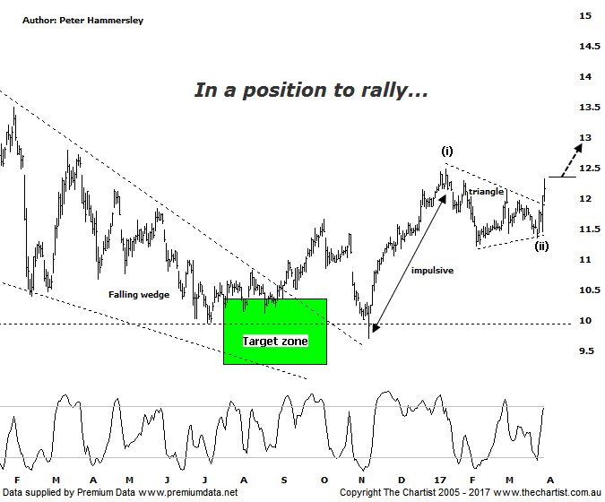

Bottom Line
31/3:
Daily Trend: Up
Weekly Trend: Up
Monthly Trend: Up
Support Levels: $11.22 / $9.70
Resistence Levels: $12.48 / $14.50
Video Analysis
Watch Video Analysis Here
Technical Discussion
Bank of QLD is one of two remaining regional banks and operates an innovative owner-managed branch system. The Company operates in two sections - Banking and Insurance. Banking includes retail banking, commercial, personal, small business loans, equipment and debtor finance, savings and transaction accounts and treasury. Whilst its main customer base is in Queensland, it is actively pursuing growth in other states. For the six months ending the 28th of February 2017 interest income decreased 5% to A$1.01B. Net interest income after loan loss provision decreased 1% to A$425M. Net interest income after loan loss provision highlights the decrease in interest earning assets and the increase in interest bearing liabilities. The dividend yield is 6.3%. Broker consensus is currently “Hold”.
Reasons to be neutral:
→ Management confident NIM will bounce back in 2H17.
→ Good leverage to the re-pricing of investor mortgage loans.
→ Yesterday’s earnings disappointed most brokers as it could be a low point in earnings trajectory.
→ Further cost savings appeared to be a priority.
→ Buyers have stepped up following the retracement into the target zone.
Yesterday’s results were met with some scepticism initially with price breaking lower intraday. However, buyers stepped up resulting in a close on the highs of the session accompanied by a massive increase in volume which can only mean the smart money was getting involved. As always, we can’t read too much into one day’s price action but it’s a step in the right direction. Our last look at BOQ was way back in July of last year where our focus of attention was on a falling wedge which appeared to have terminated in our target zone. With this type of reversal pattern price usually gets on with the job immediately although in this case that didn’t transpire. The initial breakout failed with price coming down to make a lower low for one final time. However, over the past few months a decent trend has materialised despite the consolidation that’s been unfolding over the past few weeks. The wave count both at larger and smaller degree is bullish. A clear 5-wave movement unfolded from early 2012, terminating in 2015. That was followed by an A-B-C correction which concluded within the falling wedge and the typical retracement zone as annotated. At smaller degree, waves-i and-ii appear to be in place which means what is usually the strongest leg of all the impulses is likely underway. As a minimum we’d expect the wave equality projection at $14.13 to be achieved although a continuation up toward the 1.618 projection at $15.85 is more than feasible if current traction continues. Just be aware that a sideways meander over next week or two would put a serious dent into the immediate bullish case.
Trading Strategy
You could buy right here and now with the initial stop placed just beneath the prior pivot low at $11.21. The initial target is the wave equality projection which shows good confluence with the origin of the falling wedge although if that area can be breached then a continuation toward $16.00 would be our expectation. We’re not going to make a formal recommendation this evening as we are currently holding CBA. Also most of the banks, as well as the banking sector are still exhibiting Type-A bearish divergence on the weekly charts which is reason not to be overexposed.

