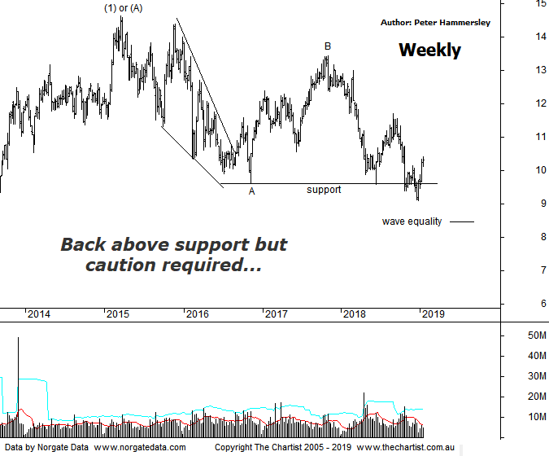

Bottom Line
18/1:
Daily Trend: Up
Weekly Trend: Up
Monthly Trend: Down
Support Levels: $9.10 / $8.51
Resistence Levels: $13.45 / $14.50 - $14.73
Video Analysis
Watch Video Analysis Here
Technical Discussion
Bank of QLD is one of two remaining regional banks and operates an innovative owner-managed branch system. The Company operates in two sections - Banking and Insurance. Banking includes retail banking, commercial, personal, small business loans, equipment and debtor finance, savings and transaction accounts and treasury. Whilst its main customer base is in Queensland, it is actively pursuing growth in other states. For the year ending the 31st of August 2018 interest income increased 1% to A$2.07B. Net interest income after loan loss provision increased 5% to A$924M. Net income decreased 5% to A$336M. Net interest income after loan loss provision highlights the business section increase of 9% to A$488M and the retail banking section increase of 3% to A$443M. The dividend yield is 7.3%. Broker consensus is currently “Sell”.
Reasons to be neutral:
→ Margins could be vulnerable.
→ Potential for further capital management.
→ Improvement in operating trends compared to the first half.
→ Net interest margin recovering and loan growth returning to positive territory.
→ Credit growth could remain subdued.
→ Higher risk profile following the recent credit rating downgrade.
→ Good leverage to the re-pricing of investor mortgage loans.
→ Attractive dividend yield.
A complex combination pattern appeared to be unfolding during our last review, which was via the weekly chart. The problem with these types of patterns is that there are many variants, and they often morph into even more complex structures. This evening I am going to put forward a simpler Elliott pattern for consideration and although it’s not perfect it adheres to most guidelines as well as all the rules. From the high of wave-(1) or-(A) a more typical zigzag could be unfolding although this may offer further downside before a low is locked in. The reason being, if a low is already locked in then wave-C has been truncated and has only just headed beneath the low of wave-A which would be a rarity. Funnily enough, the 61.8% retracement level of the whole leg higher to wave-(1) or-(A) has been tagged which is usually where we start looking for a buying opportunity. From a pure pattern perspective I’d rather price head down to the wave equality projection sitting at $8.46 although if this is to transpire price must reverse over the next week or two, as the smaller degree patterns have taken a turn for the better. Should weakness start to show then we’ll be more confident in attaining the lower target area which would complete wave-(2) or-(B). One thing is for sure, if price continues to head higher, taking out the prior pivot high at $11.71 in an impulsive manner it’s much more likely that a major low has already been locked in. Bear in mind that this isn’t our highest expectation at this juncture as the patterns still needs to prove themselves although it’s a line in the sand to concentrate on should it come under pressure over the coming weeks.
Trading Strategy
If you are a fan of the banks at these levels, then BOQ is putting its hand up for some recognition. Aggressive traders could initiate partial positions around current levels and place the protective stop just beneath a minor line of support on the daily chart (not shown) - which we’ll take a look at during this evening’s video. I wouldn’t go the full hog at current levels, and you can always top up following a higher swing low pattern or similar later down the track. I’m not making a formal recommendation due to the larger degree patterns still lacking symmetry.

