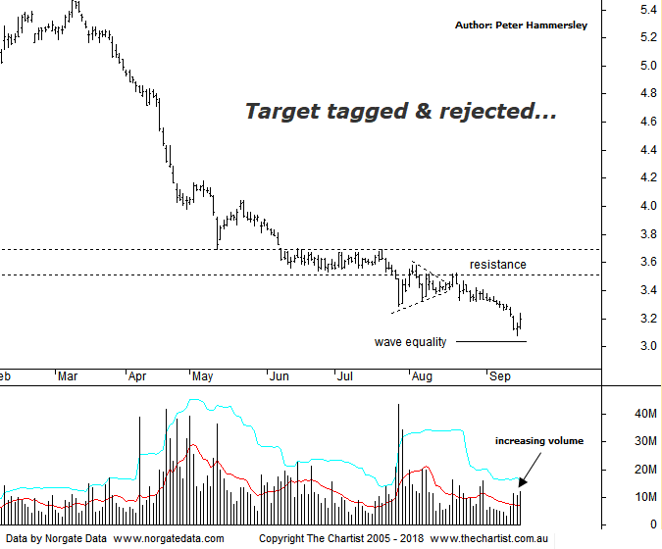

Bottom Line
17/9:
Daily Trend: Down
Weekly Trend: Down
Monthly Trend: Down
Support Levels: $3.02 / $2.72
Resistance Levels: $3.69 / $4.39 / $5.49
Video Analysis
Watch Video Analysis Here
Technical Discussion
AMP Limited (AMP) is a financial services and wealth management company operating across financial planning, insurance, asset management and retail banking. It has a significant network of 4300 advisors across Australia and New Zealand, as well as relationships with independent financial planning groups. Its asset management business is extensive with large and diversified portfolios across all major asset classes. For the six months ending the 30th of June 2018 revenues decreased 6% to A$7.15B. Net income decreased 74% to A$115M. Revenues highlight the Australian Wealth Protection(WP) section decrease of 98% to A$1M, the Wealth Management(WM) section decrease of 3% to A$716M and the New Zealand Financial Services section decrease of 14% to A$56M. Broker / Analyst consensus is currently “Sell”. The dividend yield is 9.2%.
Reasons to be cautious:
→ The fallout from the Royal commission still an unknown.
→ Increased possibility of a buyback following results.
→ A strategic review may be a potential bullish catalyst.
→ Growing Chinese investment in funds management.
→ Management hoping to double bank profits over the next five years by leveraging its adviser network.
→ Transitioning to a higher growth and less capital intensive business.
→ Continues to de-risk the life business.
→ Reforms recently announced by the government should be beneficial.
→ Improved operating momentum across wealth management continues.
There hasn't been a great deal to be enthusiastic about regarding AMP over the past few months with the downtrend being relentless. A small micro triangle had formed just beneath a zone of resistance during our last review which kept the risk to the downside. Weakness has continued to be the main theme although our target area came within a whisker of being tagged on Friday which was followed by intraday demand resulting in a close near the sessions highs. There was also an increase in volume which is always reason to sit up and take notice. There’s been good follow-through today, so it could well be that at least an interim low is locked in. It’s still far too early to suggest that a significant rally is in its early stages although a decent bounce wouldn’t surprise. The problem now of course is that the old zone of support is acting as resistance which isn’t too far above current levels. Price would need to blast through the upper boundary of resistance without hesitation to suggest a significant rally is in motion. Not impossible, but price needs to prove itself meaning we must remain cautious. The problems for the company are well documented with the Royal commission ramifications being the major stumbling block. For now, all we can do is look for current strength to continue which could take price into the zone of resistance which is the next inflection point. On the flipside, a push down through the wave equality projection at $3.00 would increase the chances of seeing the current sell-off continue.
Trading Strategy
“…Short-sell following a push beneath the lower boundary of the micro triangle whilst placing the initial stop just above the upper boundary of the new zone of resistance at $3.71 which provides a low risk entry. Use a trailing stop to manage the position although price will need to head down through the wave equality projection at $3.02 to provide an acceptable risk/reward proposition…” If you are holding short positions it may be wise to take some small profits, or at least have the protective stop at breakeven providing a risk-free trade. If it wasn’t for the zone of resistance we’d place this on the watchlist as a possible recovery play although this simply isn’t the case. As such we must continue to stand aside. Should price head back up through the zone of resistance in an impulsive manner we’ll be looking to trade the larger bounce.

