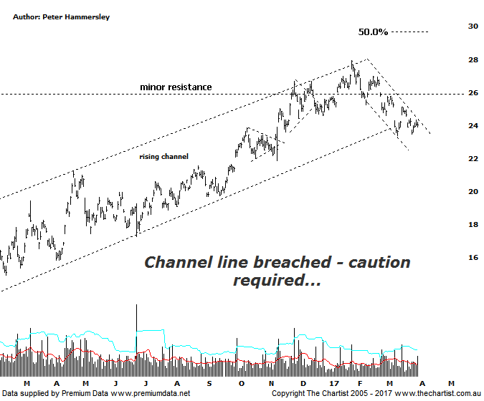

Bottom Line
31/3:
Daily Trend: Down
Weekly Trend: Down
Monthly Trend: Up
Support levels: $21.05 / $19.36
Resistance levels: $27.95 / $30.69 - $31.69
Video Analysis
Watch Video Analysis Here
Technical Discussion
BHP Billiton is a diversified natural resources company and operates through customer sector groups (CSGs). The Company operates in nine sections; Petroleum, Aluminium, Base Metals, Diamonds and Specialty Products, Stainless Steel Materials, Iron Ore, Manganese, Metallurgical Coal and Energy Coal. In May 2014, Cassini Resources acquired BHP Billiton Limited's West Musgrave Project. For the six months ending the 31st of December 2016 revenues increased 20% to $18.8B. Net income was $3.2B against a loss of $5.67B. Revenues highlight the coal section increase of 68% to $3.93B and the Iron Ore section increase of 30% to $6.93B. Broker/Analyst consensus is currently “Hold”. The dividend yield is 1.6%.
Reasons to be cautiously optimistic (downside short-term):
→ Management continuing to focus on costs and reducing debt.
→ Won the rights to develop the Trion deep water oil project in the Gulf of Mexico.
→ Growth options remain.
→ 2017 should see reduced debt with the potential for shareholder returns.
→ The surge in coal prices adds plenty of weight to the earnings outlook.
→ Rising commodity prices provides upside risk.
→ Exposure to oil could be beneficial when compared to its peers.
Price was heading back down to the lower boundary of the rising channel during our last review which needed to hold to keep the ongoing bullish case alive and well. However, we also noted that weakness was coupled with increasing volume which is always a warning sign that the smart money is starting to exit. Either way, the lower boundary of the channel has been overcome which now opens the door to see a deeper retracement. What we must remember though is that after many years of weakness the company has rallied extremely well resulting in a gain of almost 100% from the low made in January 2016. Nothing goes up indefinitely and it could be that a typical retracement is now underway. Should this be the way forward then price could head down into the 50% - 61.8% retracement zone as annotated sitting between $21.00 - $19.36 which is still a reasonable percentage loss from current levels. A pull-back of that magnitude isn’t going to happen overnight though and it could take several months to unfold - should it transpire. There is the potential for some bullish divergence to form over the coming days which if correct would be expected to trigger a bounce although at this stage that’s all we’d be looking for, a rally only and nothing more. Interestingly, RIO has been heading down in an impulsive movement over the past few weeks whereas BHP’s retracement looks a little less decisive meaning it could prove to be more resilient out of the two. Just something to be aware of if we are to see further weakness over the coming weeks. As it stands right here and now it would take a push up above $26.22 before thinking in terms of avoiding a deeper retracement although a continuation above the prior pivot high at $27.95 to suggest the prior uptrend is back in motion.
Trading Strategy
It’s undoubtedly the financials, and especially the banks that have been the driving force behind broader market strength recently with the Materials sector taking more of a breather. This trait could continue over the short-term although we are still bullish on the likes of BHP, RIO & S32 over the medium to longer term. However, there is plenty of talk around iron ore retracing and with volatility in oil and the US dollar increasing it does keep the door open to get the deeper retracement. Either way, the patterns at the moment aren’t offering a trade meaning we’ll remain sidelined.

