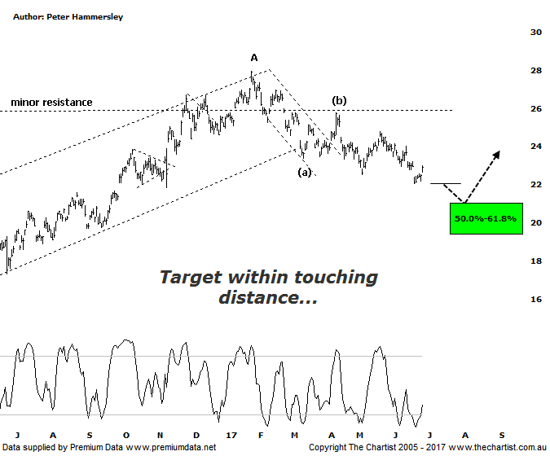

Bottom Line
28/6:
Daily Trend: Neutral
Weekly Trend: Down
Monthly Trend: Down
Support levels: $21.05 / $19.36 / $14.06
Resistance levels: $27.95 / $30.69 - $31.69
Video Analysis
Watch Video Analysis Here
Technical Discussion
BHP Billiton is a diversified natural resources company and operates through customer sector groups (CSGs). The Company operates in nine sections; Petroleum, Aluminium, Base Metals, Diamonds and Specialty Products, Stainless Steel Materials, Iron Ore, Manganese, Metallurgical Coal and Energy Coal. In May 2014, Cassini Resources acquired BHP Billiton Limited's West Musgrave Project. For the six months ending the 31st of December 2016 revenues increased 20% to $18.8B. Net income was $3.2B against a loss of $5.67B. Revenues highlight the coal section increase of 68% to $3.93B and the Iron Ore section increase of 30% to $6.93B. Broker/Analyst consensus is currently “Hold”. The dividend yield is 1.7%.
Reasons to be cautiously optimistic (downside short-term):
→ Bulk commodities are finding support.
→ Capacity could boost production by around 20%.
→ More aggressive development of US shale looking likely.
→ Won the rights to develop the Trion deep water oil project in the Gulf of Mexico.
→ 2017 should see reduced debt with the potential for shareholder returns.
→ Rising commodity prices provides upside risk.
→ Exposure to oil could be beneficial when compared to its peers.
The monthly chart last time showed that further downside was probable with the ideal situation being to see a rotation down toward the typical retracement zone either side of $20.00. That zone isn’t too far beneath current levels meaning it could only be a matter of weeks before an opportunity arises. Notwithstanding the past couple of days where price has bounced, price action has been sedate to say the least with a sideways meander with a bias to the downside unfolding since March of this year. Regarding the wave count, the patterns continue to look promising with wave-(c) looking to complete shortly at those slightly lower levels. In turn, this should complete a larger degree wave-B which would offer a multi-month and perhaps even multi-year trend higher, albeit within a larger corrective pattern. On the weekly chart, (not shown) there is bullish divergence in place with price making a lower low whilst our oscillator has failed to confirm that weakness by making a higher low. However, it’s yet to trigger although a few more days like the last two would likely do just that. Even then, this wouldn’t suggest a significant low is in place although it would likely mean that last week’s low at $22.06 would likely remain intact until our oscillator unwinds all the way into the overbought position which on the larger timeframe is going to take several weeks as a minimum. From a time perspective, the retracement at the recent pivot low took almost exactly 38.2% of the time taken by the prior leg which is our minimum expectation regarding a countertrend movement. In other words, the one final probe down required should complete the larger corrective pattern.
Trading Strategy
We haven’t wanted to be involved in the miners for some time now and it’s still too early to be jumping in with both feet. That said, some of the big miners are starting to look interesting although as mentioned above, short-term weakness here would be ideal in presenting confluence both in terms of price and time. As such, we’ll continue to stand aside although the likes of BHP & RIO are starting to hit our watchlist. If we are correct, then there is plenty of scope for upside once slightly lower targets are reached.

