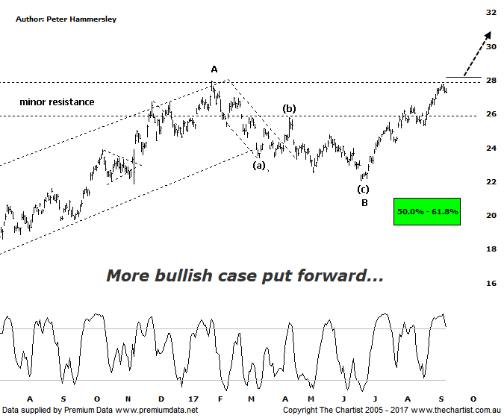

Bottom Line
8/9:
Daily Trend: Up
Weekly Trend: Up
Monthly Trend: Up
Support levels: $21.05 / $19.36 / $14.06
Resistance levels: $27.95 / $30.69 - $31.69
Video Analysis
Watch Video Analysis Here
Technical Discussion
BHP Billiton is a diversified natural resources company and operates through customer sector groups (CSGs). The Company operates in nine sections; Petroleum, Aluminium, Base Metals, Diamonds and Specialty Products, Stainless Steel Materials, Iron Ore, Manganese, Metallurgical Coal and Energy Coal. In May 2014, Cassini Resources acquired BHP Billiton Limited's West Musgrave Project. For the year ending the 30th of June 2017 revenues increased 24% to $38.29B. Net income was $5.89B against a loss of $6.39B. Revenues highlight the Iron Ore, Avg. price per metric ton increase of 32% to $58 per metric ton, Iron Ore Production at Wheelarra increasing 20% to 27M metric tons. Broker/Analyst consensus is currently “Hold”. The dividend yield is 1.9%.
Reasons to be cautiously optimistic (downside short-term):
→ Capital management looking more feasible in FY19 including a share buy-back.
→ Net debt decreasing on the back of strong free cash flow.
→ Divestment of US onshore and the cessation of work on Jansen in 2018.
→ Capacity could boost production by around 20%.
→ More aggressive development of US shale looking likely.
→ Won the rights to develop the Trion deep water oil project in the Gulf of Mexico.
→ Rising commodity prices provides upside risk.
→ Exposure to oil could be beneficial when compared to its peers.
One big clue regarding Elliott wave patterns is whether price is impulsive or corrective in nature. We’ve been looking for strength over the past three months or so to be part of a larger corrective pattern though the continued strong and clean price action cannot be ignored. This is much more indicative of the longer-term uptrend being back in motion. As such, we have amended our wave count this evening to incorporate the turnaround in the smaller degree patterns. Although price didn’t quite hit the typical retracement zone as shown either side of $20.00, it came reasonably close meaning it’s much more likely that wave-B is already in position. We often look to time analysis to confirm whether a corrective pattern has run its course. A retracement should take at least 38.2% of the time taken by the prior move which in this instance is a box that can be ticked. In fact the recent pivot low was made within two days of the 38.2% time projection which is close enough on this timeframe. Should our wave count be correct then price should head up to the wave equality projection sitting at $35.95 over the coming months which is a move worthy of being involved with. One slight problem is the zone of resistance although price is sitting in exactly the right place to take it on. A comprehensive break up through $28.00 would be a confidence booster and suggest that the trend is going to continue making it a level to keep a close eye on over the coming days and weeks. It would now take a push beneath $24.22 to move back to a neutral stance and a continuation beneath $22.00 to invalidate our wave count.
Trading Strategy
As stated above, the smaller degree patterns have taken a turn for the better although at this stage a low risk entry isn’t presenting itself. We’d prefer to be buyers once the zone of resistance is overcome once and for all. Price often comes back to retest old resistance/new support which is where the buying opportunity may present itself. We have exposure to the sector via S32 although if a low risk entry presents itself shortly, one will be forthcoming in BHP. A little more patience required during the interim though.

