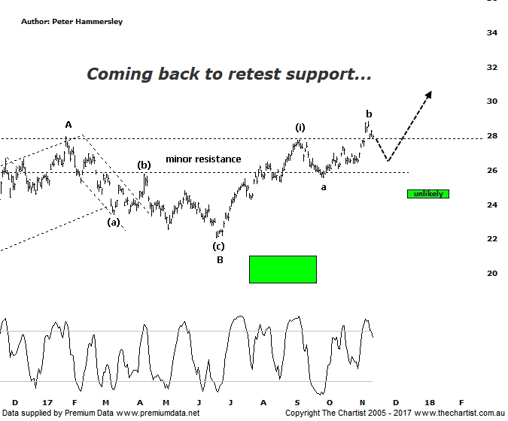

Bottom Line
14/11:
Daily Trend: Up
Weekly Trend: Up
Monthly Trend: Up
Support levels: $25.54 - $25.30 / $22.06
Resistance levels: $28.81 / $29.59 / $33.26 - $36.05
Video Analysis
Watch Video Analysis Here
Technical Discussion
BHP Billiton is a diversified natural resources company and operates through customer sector groups (CSGs). The Company operates in nine sections; Petroleum, Aluminium, Base Metals, Diamonds and Specialty Products, Stainless Steel Materials, Iron Ore, Manganese, Metallurgical Coal and Energy Coal. In May 2014, Cassini Resources acquired BHP Billiton Limited's West Musgrave Project. For the year ending the 30th of June 2017 revenues increased 24% to $38.29B. Net income was $5.89B against a loss of $6.39B. Revenues highlight the Iron Ore, Avg. price per metric ton increase of 32% to $58 per metric ton, Iron Ore Production at Wheelarra increasing 20% to 27M metric tons. Broker/Analyst consensus is currently “Buy”. The dividend yield is 3.8%.
Reasons to be cautiously optimistic (downside short-term):
→ Capital management looking more feasible in FY19 including a share buy-back.
→ Net debt decreasing on the back of strong free cash flow.
→ Divestment of US onshore and the cessation of work on Jansen in 2018.
→ Capacity could boost production by around 20%.
→ More aggressive development of US shale looking likely.
→ Won the rights to develop the Trion deep water oil project in the Gulf of Mexico.
→ Rising commodity prices provides upside risk.
→ Exposure to oil could be beneficial when compared to its peers.
One brief probe down to the target area just above $24.00 would have been ideal following our last look at BHP although this hasn’t transpired. Instead, buyers have remained committed with price breaking up through the minor zone of resistance a little sooner than anticipated. That said, there is still scope to see one final probe down to complete a running or expanded flat pattern although we’ll discuss these in more detail during the video. It’s now looking unlikely that the typical retracement zone just beneath the low of wave-a is going to be tagged. From an Elliott stance there is still every reason to be bullish over the medium to longer term. I have pencilled in wave-b as completing a few days ago although that high at $28.81 needs watching closely over the coming days. If it’s overcome, then the smaller degree count shown is incorrect which means wave-(iii) higher is already in motion. The reason being, wave-b will usually hit and reject from the 1.382 projection of wave-a which is exactly what’s unfolded. In other words, a probe above that level invalidates our smaller degree count although it would undoubtedly be extremely positive. Whether we see slightly lower levels or not, the risk remains to the upside. I would be concerned should the typical retracement zone at $24.26 be overcome as the retracement would then be too deep which automatically rings the alarm bells. For now though, price is doing everything asked of it despite the profit-taking over the past few days, plus the possibility of heading back down toward the $26.00 area over the coming days.
Trading Strategy
The patterns on the chart of RIO are looking slightly more bullish which comes on the back of price sitting above the old zone of resistance/new zone of support as opposed to on it which is the case here. That said, if one is going to trend then the other is almost certainly going to follow. We currently hold positions in RIO, S32 and ASL so we have exposure to the sector without getting involved here. If you are looking for a trade though, a low risk entry is available. The strategy is to buy following a push above last Thursday’s high at $28.81 with the protective stop placed just beneath the zone of support at $25.53 which provides a low risk entry. A trailing stop should be used to manage the position although the medium-term target is the next zone of resistance up around $36.00.

