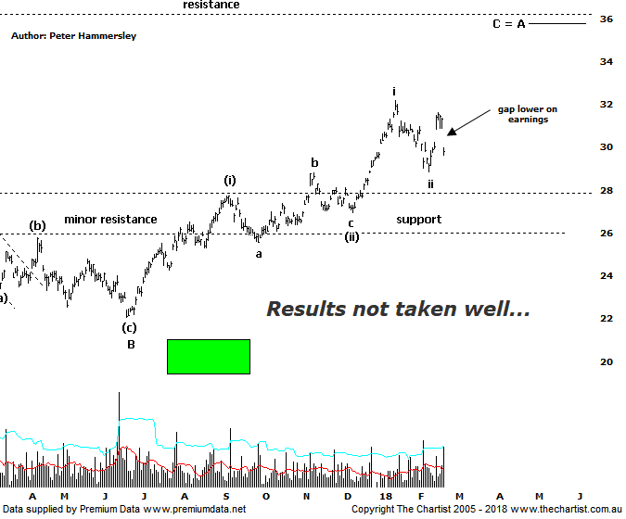

Bottom Line
21/2:
Daily Trend: Neutral
Weekly Trend: Up
Monthly Trend: Up
Support levels: $28.85 - $28.81 / $25.54 - $25.30 / $22.06
Resistance levels: $32.16 / $33.26 - $36.05
Video Analysis
Watch Video Analysis Here
Technical Discussion
BHP Billiton is a diversified natural resources company and operates through customer sector groups (CSGs). The Company operates in nine sections; Petroleum, Aluminium, Base Metals, Diamonds and Specialty Products, Stainless Steel Materials, Iron Ore, Manganese, Metallurgical Coal and Energy Coal. In May 2014, Cassini Resources acquired BHP Billiton Limited's West Musgrave Project. For the year ending the 30th of June 2017 revenues increased 24% to $38.29B. Net income was $5.89B against a loss of $6.39B. Revenues highlight the Iron Ore, Avg. price per metric ton increase of 32% to $58 per metric ton, Iron Ore Production at Wheelarra increasing 20% to 27M metric tons. Broker/Analyst consensus is currently “Buy”. The dividend yield is 3.3%.
Reasons to be cautiously optimistic (downside risk short-term):
→ Capital management looking more feasible in FY19 including a share buy-back.
→ Net debt decreasing on the back of strong free cash flow.
→ Divestment of US onshore and the cessation of work on Jansen in 2018.
→ Capacity could boost production by around 20%.
→ More aggressive development of US shale looking likely.
→ Won the rights to develop the Trion deep water oil project in the Gulf of Mexico.
→ Rising commodity prices provides upside risk.
→ Exposure to oil could be beneficial when compared to its peers.
It would be fair to say that the market wasn’t overly enamoured with BHP’s results with a large gap down witnessed today culminating in around a 5% decline. However, although results may have been slightly beneath consensus they certainly weren’t catastrophic. Plus, the $0.55 dividend came as a pleasant surprise to most. Managements debt target has now been achieved which opens the door for better returns to shareholders. The one problematic area was cost performance which reportedly came down to operational issues at various sites. So how does all this affect the patterns we’ve been following? It doesn’t. Yes, we could have done without today’s decline although as always, we don’t read too much into one day’s price action. Over the next few days price is just as likely to recover and head higher as opposed to continuing down. I’ve now pencilled in minor degree waves-i and-ii meaning it’s important that the pivot low made a couple of weeks ago at $28.85 isn’t overcome. This wouldn’t invalidate the patterns, but it would put serious pressure on them. Our wave count is invalidated if the low of wave-(ii) at $26.93 is overcome as this would suggest a corrective pattern higher has been unfolding from the June 2017 lows which would obviously be less than ideal. Having said that, there is a solid zone of support above $26.00 which from a more conventional pattern perspective is a big positive. Should today’s price action prove to be an overreaction, with strength returning immediately we are still confident of attaining the wave equality projection and the next line of resistance circa $36.00 in reasonably quick fashion. The reaction over next few days should provide a big clue as to where price heads over the coming weeks.
Trading Strategy
As we mentioned in Friday’s review of the XJO, with results season in full flow this week we must expect the unexpected. Unfortunately, in this instance it’s been a negative reaction to results which is more significant to us as we hold long positions. However, enough traction has been gleaned over the past few weeks for us to move the protective stop to breakeven although there isn’t much wiggle room left if we are to remain in the trade. If you aren’t already involved it’s best to continue to stand aside.

