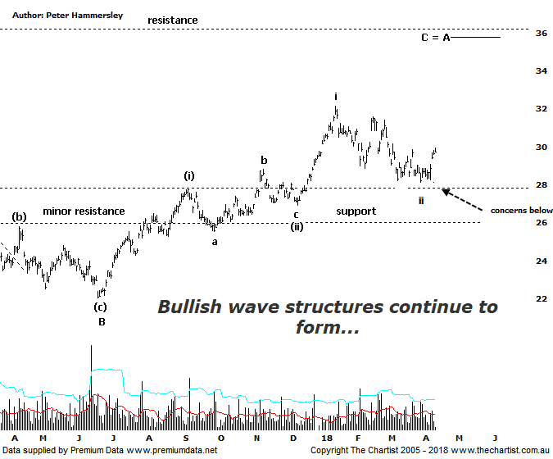

Bottom Line
13/4:
Daily Trend: Up
Weekly Trend: Down
Monthly Trend: Up
Support levels: $28.13 - $27.73 / $25.54 - $25.30 / $22.06
Resistance levels: $32.16 / $33.26 - $36.05
Video Analysis
Watch Video Analysis Here
Technical Discussion
BHP Billiton is a diversified natural resources company and operates through customer sector groups (CSGs). The Company operates in nine sections; Petroleum, Aluminium, Base Metals, Diamonds and Specialty Products, Stainless Steel Materials, Iron Ore, Manganese, Metallurgical Coal and Energy Coal. In May 2014, Cassini Resources acquired BHP Billiton Limited's West Musgrave Project. For the six months ending the 31st of December 2017 revenues increased 16% to $21.78B. Net income before extraordinary items increased 20% to $3.84B. Revenues highlight the Copper section increase of 52% to $6.38B, the Iron Ore, Avg. Price per Met. Ton, total increase of 4% to $57 per metric ton, Iron Ore Production (MT) - Wheelarra increase of 29% to 16.5M metric tons. Broker/Analyst consensus is currently “Buy”. The dividend yield is 3.6%.
Reasons to be cautiously optimistic (downside risk short-term):
→ The oil business could be enough of a differentiator to command a premium.
→ The disposal of the shale business is considered a positive catalyst.
→ Strong demand for high-quality iron ore continues.
→ The interim dividend represented an impressive 72% payout ratio.
→ US$1.9B could be paid in cash on top of the 50% ratio final dividend.
→ Capacity could boost production by around 20%.
→ Rising commodity prices provides upside risk.
→ Reversing from a zone of support.
With price heading down to the upper boundary of the zone of support in a clearly defined a-b-c pattern there was every reason to be optimistic during our last review. An upside break was required and although price has hesitated over the past few weeks strength has finally kicked in over the past few days. At this stage that’s all we can ask for although it’s important that momentum isn’t lost over the next couple of weeks or so. Price action here on in needs to be strong and impulsive in nature. Bullish divergence on this daily chart has likely been the trigger for the recent push north although the potency of the move means our oscillator is already sitting in the overbought position. However, this doesn’t automatically mean that momentum is going to wane, especially as price has rejected from the zone of support. From an Elliott stance nothing changes with a series of first and second legs likely underway from larger degree wave-B which keeps the door firmly open for a multi-week and probably even a multi-month trend to develop. The prerequisite is that the zone of support holds during any subsequent weakness. A quick look at the weekly chart (not shown) shows that the wave equality projection of a larger pattern sits up at $35.95 although that’s still a decent percentage gain from current levels. Interestingly, that aforementioned level also coincides with the next significant zone of resistance making it even more significant. We’ll keep an eye on it although those higher levels are unlikely to come under pressure any time soon. From a fundamental point of view brokers have become more positive on the stock with some of the reasons why mentioned above.
Trading Strategy
Our headline last time was “… Support to present a buying opportunity…”. This is exactly what transpired, and we currently hold long positions from $28.68. Although price is heading in the right direction it’s still too early to reduce the risk, especially as it was already a low risk entry. As I just mentioned in our review of PRU, with the broader market the way it is we need to allow plenty of wiggle room as it’s very easy to get stopped out during what essentially is now normal market noise. If you aren’t already involved there’s every reason to stand aside although it may be worth looking at our review of RIO on Wednesday which also looks strong.

