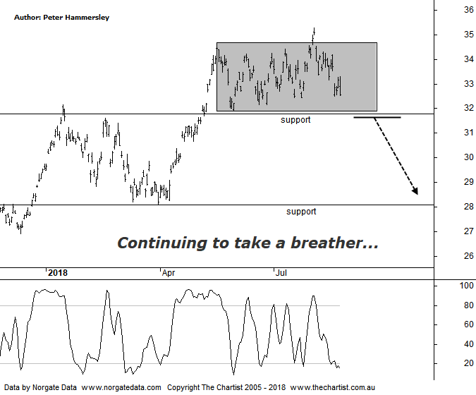

Bottom Line
21/8:
Daily Trend: Down
Weekly Trend: Down
Monthly Trend: Up
Support levels: $32.16 - $31.90 / $28.13 - $27.73 / $25.54 - $25.30
Resistance levels: $34.63 - $36.59
Video Analysis
Watch Video Analysis Here
Technical Discussion
BHP Billiton is a diversified natural resources company and operates through customer sector groups (CSGs). The Company operates in nine sections; Petroleum, Aluminium, Base Metals, Diamonds and Specialty Products, Stainless Steel Materials, Iron Ore, Manganese, Metallurgical Coal and Energy Coal. In May 2014, Cassini Resources acquired BHP Billiton Limited's West Musgrave Project. Full-year net profit dropped 37% following write-downs on its oil business. Underlying profit rose 33% to $US8.93 billion against expectations from analysts of around $9.1 billion. However, the company surprised with a fully franked final dividend of 63 US cents a share - up 20 cents on a year ago. Broker/Analyst consensus is currently “Hold”. The dividend yield is 3.4%.
Reasons to be cautiously optimistic:
→ The oil business could be enough of a differentiator to command a premium.
→ The disposal of the shale business is considered a positive catalyst.
→ Strong demand for high-quality iron ore continues.
→ The interim dividend represented an impressive 72% payout ratio.
→ US$1.9B could be paid in cash on top of the 50% ratio final dividend.
→ Capacity could boost production by around 20%.
→ Rising commodity prices provides upside risk.
→ Reversing from a zone of support.
Price action with BHP does tend to be choppy and messy in nature which doesn’t bode well for making a high probability wave count. The continued sideways move has also been enough for us to remove our labelling and concentrate on more conventional pattern analysis. The headline pattern is still the consolidation phase that commenced back in mid-May of this year. The big positive is that the trend up to that point in time was extremely strong which means the risk remains to be upside over the medium to longer-term. For the moment though price is quite happy to chop sideways with a bias to the downside which could result in the line of support as annotated just beneath $32.00 being tagged over next few weeks. Although it’s only a minor line of support, a break beneath would open the door for a deeper retracement. Indeed, the next area of support sits around $28.00 which would be a high probability target zone if the current consolidation pattern breaks to the downside. It would now take a push above the prior pivot high at $35.29 to get the bullish case back on track although what the trigger for such a move is going to be remains to be seen. Today the company issued results which came in just beneath consensus although the dividend offset some of the negativity following the mild disappointment in earnings. For now we’ll concentrate on both areas of support as a few buyers could be waiting in the wings at those lower levels.
Trading Strategy
The lack of follow-through to the upside has resulted in us adjusting the protective stop up to $31.89 which will lock in a reasonable profit should price continue to head lower from here. This is a logical area for the protective stop which coincides with the prior pivot low and the line of support. If we are stopped out we can always top up following signs of strength around the next zone of support circa $28.00. If you aren’t already involved continue to stand aside.

