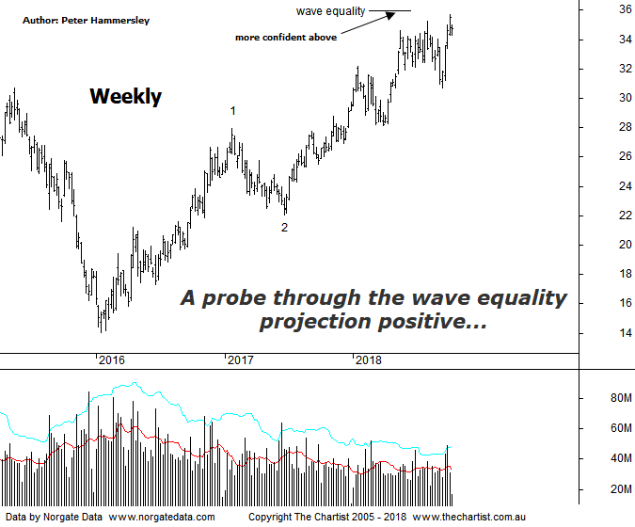

Bottom Line
10/10:
Daily Trend: Down
Weekly Trend: Up
Monthly Trend: Up
Support levels: $28.13 - $27.73
Resistance levels: $34.63 - $36.59
Video Analysis
Watch Video Analysis Here
Technical Discussion
BHP Billiton is a diversified natural resources company and operates through customer sector groups (CSGs). The Company operates in nine sections; Petroleum, Aluminium, Base Metals, Diamonds and Specialty Products, Stainless Steel Materials, Iron Ore, Manganese, Metallurgical Coal and Energy Coal. In May 2014, Cassini Resources acquired BHP Billiton Limited's West Musgrave Project. Full-year net profit dropped 37% following write-downs on its oil business. Underlying profit rose 33% to $US8.93 billion against expectations from analysts of around $9.1 billion. However, the company surprised with a fully franked final dividend of 63 US cents a share - up 20 cents on a year ago. Broker/Analyst consensus is currently “Hold”. The dividend yield is 4.8%.
Reasons to be cautious:
→ The oil business could be enough of a differentiator to command a premium.
→ The disposal of the shale business is considered a positive catalyst.
→ Strong demand for high-quality iron ore continues.
→ The interim dividend represented an impressive 72% payout ratio.
→ US$1.9B could be paid in cash on top of the 50% ratio final dividend.
→ Capacity could boost production by around 20%.
→ Rising commodity prices provides upside risk.
→ A line of support breached.
The wave equality projection had been tagged and rejected just prior to our last review although buyers have once again stepped up and pushed price up through the prior pivot high. Still, unless price can break up through the wave equality projection at $35.95 in a move that sticks there’s always the possibility that a corrective pattern higher has been unfolding off the early 2016 lows. I have labelled this chart in a more bullish light, but the patterns need to prove themselves. As always, the further price heads up through the wave equality projection the greater the chance that a more bullish 5-wave move is unfolding off those 2016 lows. Should the bullish scenario come to fruition price should continue up to the 1.618 projection of wave-1 projected from the low of wave-2 which provides a target up at $44.53. This is still a healthy percentage gain from current levels. From a pure pattern perspective this would be ideal as normally in stocks wave-3 proves to be the extended leg although in futures it tends to be wave-5. My only real concern is the broader market which has started to struggle over the past few weeks. Although it’s feasible that the likes of BHP and Rio can buck the trend of the XJO it’s much more unlikely to transpire in a weak market environment. Should price reject from current levels we’ll start making downside targets although until this transpires we’ll go with the flow and run with this more bullish labelling of price. Brokers continue to sit on the fence with many suggesting that commodity prices are going to be the headwind moving forward. Time will tell.
Trading Strategy
Until price gets up through the wave equality projection at $35.95 it’s best to stand aside. However, that line in the sand aligns nicely with the next area of resistance which runs up to $36.50 so it may be wise to wait until resistance is overcome before looking for a trade to the upside. This will be our strategy and we are quite happy to stand aside until the next opportunity arises.

