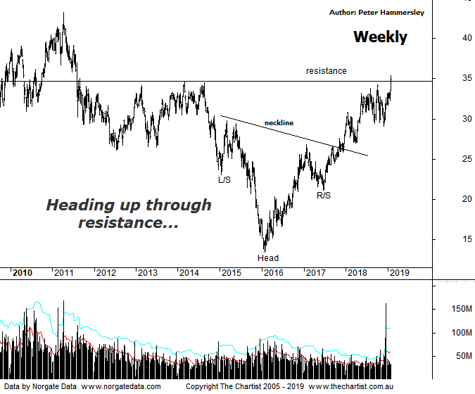

Bottom Line
31/1:
Daily Trend: Up
Weekly Trend: Up
Monthly Trend: Up
Support levels: $34.21 - $33.25 / $27.62 - $26.97
Resistance levels: $43.26 - $43.43 (All-time high)
Video Analysis
Watch Video Analysis Here
Technical Discussion
BHP Billiton is a diversified natural resources company and operates through customer sector groups (CSGs). The Company operates in nine sections; Petroleum, Aluminium, Base Metals, Diamonds and Specialty Products, Stainless Steel Materials, Iron Ore, Manganese, Metallurgical Coal and Energy Coal. In May 2014, Cassini Resources acquired BHP Billiton Limited's West Musgrave Project. Full-year net profit dropped 37% following write-downs on its oil business. Underlying profit rose 33% to $US8.93 billion against expectations from analysts of around $9.1 billion. However, the company surprised with a fully franked final dividend of 63 US cents a share - up 20 cents on a year ago. Broker/Analyst consensus is currently “Hold”. The dividend yield is 4.8%.
Reasons to be more optimistic:
→ The oil business could be enough of a differentiator to command a premium.
→ The disposal of the shale business is considered a positive catalyst.
→ Strong demand for high-quality iron ore continues.
→ The interim dividend represented an impressive 72% payout ratio.
→ US$1.9B could be paid in cash on top of the 50% ratio final dividend.
→ Capacity could boost production by around 20%.
→ Rising commodity prices provides upside risk.
→ A line of resistance overcome.
The big miners have been enjoying a good run over the past few weeks, with BHP here gaining almost 22% from the low made in November of last year. Recent price action has become impulsive in nature which is also a step in the right direction. We’ll stick with the weekly chart this evening which shows that price is testing the line of resistance. If this area can be cleared it should be onwards and upwards toward all-time highs circa $43.43 made all the way back in early 2008. The headline pattern is still the large H&S, with the neckline already overcome with a degree of attitude. If we measure the depth of the pattern and project it from the breakout the target aligns very nicely with those aforementioned all-time highs providing an area of confluence. Nothing is guaranteed although the more confluence we have, the greater the chance it’s going to be significant which in this instance advocates higher prices. Before getting overly excited we still need to get up through the line of resistance in a move that sticks although we are on the verge of doing exactly that. The only real issue is that on the daily chart (not shown) Type-A bearish divergence is in place with price making a higher high whilst our oscillator has failed to confirm that strength by making a lower high. That said, it’s yet to trigger meaning at this stage it’s something to watch only. Price would need to head down immediately - and by that I mean over the next day or two for the divergence to become influential. This would likely cause a stall in the recent rally.
Trading Strategy
One of our trading rules is that we don’t put forward formal recommendations when bearish divergence is in place, meaning for now we’ll continue to stand aside. However, should price continue higher immediately we’ll be looking for a retest of old resistance/new support, or perhaps even a consolidation pattern as both would provide low risk entries. We’ll place this on the short-term watchlist so don’t be surprised to see a formal recommendation in the position status page before doing another review.

