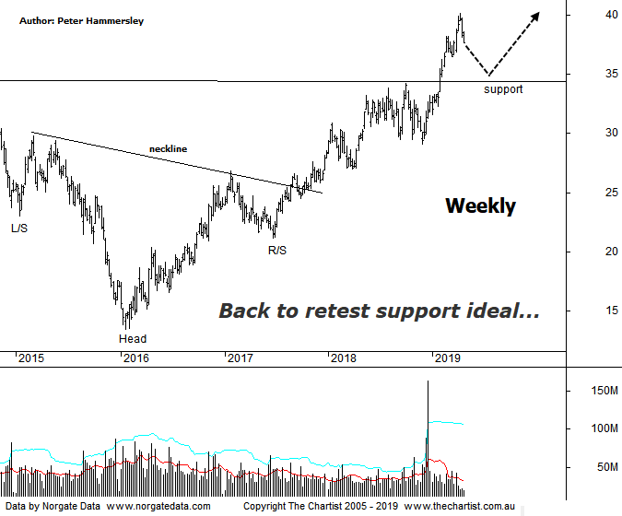

Bottom Line
26/4:
Daily Trend: Down
Weekly Trend: Up
Monthly Trend: Up
Support levels: $34.21 - $33.25 / $27.62 - $26.97
Resistance levels: $43.26 - $43.43 (All-time high)
Video Analysis
Watch Video Analysis Here
Technical Discussion
BHP Billiton is a diversified natural resources company and operates through customer sector groups (CSGs). The Company operates in nine sections; Petroleum, Aluminium, Base Metals, Diamonds and Specialty Products, Stainless Steel Materials, Iron Ore, Manganese, Metallurgical Coal and Energy Coal. In May 2014, Cassini Resources acquired BHP Billiton Limited's West Musgrave Project. For the six months ending the 31st of December 2018 revenues increased 1% to $20.74B. Net income before extraordinary items decreased 3% to $4.06B. Revenues highlight the Petroleum section increase of 24% to $3.2B, the Coal section increase of 11% to $4.51B, the China section increase of 6% to $11.18B and the Europe section increase of 20% to $983M. Net income was offset by Interest on bank loans and overdrafts. Broker/Analyst consensus is currently “Hold”. The dividend yield is 4.4%.
Reasons to be more optimistic:
→ Management confident that production will be higher in the second half, reversing productivity losses.
→ Net debt now within the company’s targets offering opportunities for buybacks and higher dividends.
→ Benefiting from a strong pricing environment, especially for iron ore and coking coal.
→ Spot commodity prices remain robust.
→ Showing strong capital discipline.
→ The oil business could be enough of a differentiator to command a premium.
→ Capacity could boost production by around 20%.
→ Rising commodity prices provides upside risk.
→ A line of resistance overcome.
We’ll stick with the weekly chart this evening which shows that the longer-term bullish case is still firmly on track. The ideal situation following our last review was to see a rotation down toward the zone of support but although initial weakness kicked in those lower levels weren’t tagged. However, weakness has set in over the past couple of weeks so it could be that our wanted retest of the breakout area is going to occur over the coming weeks. A quick look at the daily chart (not shown) shows that a smaller degree 5-wave move is likely locked-in meaning a symmetrical a-b-c retracement could be underway. This provides a target between $33.29 – 34.60 which aligns very nicely with the new zone of support. In other words, there is confluence at those lower levels which increases the likelihood of the current retracement continuing. This weekly chart shows a large H&S reversal pattern which commenced all the way back in 2015. As is normally the case, these larger patterns offer attractive target areas which in this instance sits just above $40.00. Interestingly, all-time highs are slightly above that area so bigger picture it could be that price is going to be drawn toward those higher levels circa $43.43 although that’s something to look out for further down the track. For now, profit-taking has set in, with price action looking impulsive in nature albeit it’s only over the short-term. The likes of BHP and RIO have been pushing the XJO up over the past few months so it shouldn’t come as any great surprise that the sector is taking a breather. In fact, the Banking sector is currently taking its turn in pushing the XJO higher although whether it proves to be the start of something more bullish is debatable.
Trading Strategy
If we are correct, then the next buying opportunity could present itself around the zone of support circa $35.00 although it could take several weeks before heading down to that area - assuming it does. With better data coming out of China, as well as concerns regarding the global economy fading there’s no reason why the big miners can’t continue with the trend seen of late, albeit following short-term weakness. For now, we’ll stand aside but our interest in a trade will be rekindled should price head down toward the line of support.

