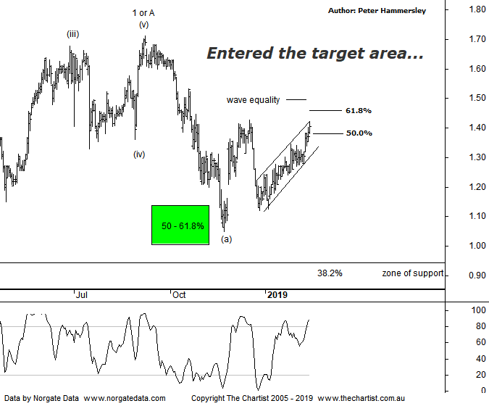

Bottom Line
14/2:
Daily Trend: Up
WeeklyTrend: Up
Monthly Trend: Down
Support Levels: $1.05 - $1.00 / $0.95 - $0.88
Resistance Levels: $1.50 / $1.71 / $1.935
Video Analysis
Watch Video Analysis Here
Technical Discussion
Accent Group Limited (AX1), formerly RCG Corporation Limited, is an investment holding company. The Company owns and operates a range of footwear and apparel businesses in the performance and active lifestyle sectors. It operates through four sections: The Athlete's Foot, a franchisor and retailer of general sports footwear. The Company’s brand includes Athlete’s Foot CAT, Dr. Martens, Merrell, Palladium, Platypus, Podium sports, saucony, Skechers, Sperry, Stance, Hype dc, SHUBAR, Timberland, and VANS. For the year ending the 01st July 2018 revenues increased 11% to A$703.2M. Net income increased 51% to A$44M. Revenues reflect the increase in sales to customers of 11% to A$675.6M, other revenue increased 19% to A$3.1M. Net income benefited from the Impairment of HYPE DC brand name which decreased from A$9.7M to zero. Broker consensus is “Buy”. The dividend yield is 4.9%.
Reasons to remain bullish longer term (caution short-term):
→ Online sales growth has been exceptionally strong due to continued investment.
→ Upside risk to guidance.
→ The company’s margin dollar growth is a head of sales growth implying reducing discounts has been successful.
→ Competition from Amazon hasn’t had a limited impact.
→ Exceptionally strong longer-term uptrend intact.
→ Attractive dividend yield.
Although price had already tagged the typical retracement zone during our last review the speed of the move strongly implied that the corrective pattern higher hadn’t run its course. We always need to see symmetry from a time perspective which means the corrective pattern taking at least 38.2% of the time taken by the prior leg which in this instance hasn’t come anywhere near to being achieved. This is still the case although there is now much more symmetry both from a pattern and time perspective. We can also see that price has now entered the 50% - 61.8% retracement zone although there is room for the current bounce to continue for a while longer. However, upside should be limited if our wave count proves to be correct. Zooming into the more recent price action shows price has been heading higher within a rising channel although it has been overlapping in nature suggesting it’s not the start of something more bullish. For now we’ll continue to watch the channel and the reaction whilst in the typical retracement zone as this will be key to where price heads over the coming weeks. From an Elliott stance the recent rally should complete wave-(b) which in turn would set the stage for another leg South similar in length to the retracement into wave-(a). On the weekly chart (not shown) a solid zone of support either side of $0.90 is prominent meaning any ongoing retracement could terminate in that area. It would take a push above the typical retracement zone at $1.46 before thinking in terms of challenging the significant highs made in September last year circa $1.71. Should this transpire it’s likely going to be followed by another decent leg South.
Trading Strategy
If you are actively looking for shorting opportunities, then it’s worth putting AX1 on the watchlist. Just bear in mind that the wave equality projection sits slightly above the 61.8% retracement level meaning this could be one of those rare occasions when the typical retracement zone is penetrated before price reverses. For now, we are not interested in putting forward short set-ups as this is going against the broader market trend. This could change of course although from now it’s better to go with the flow.

