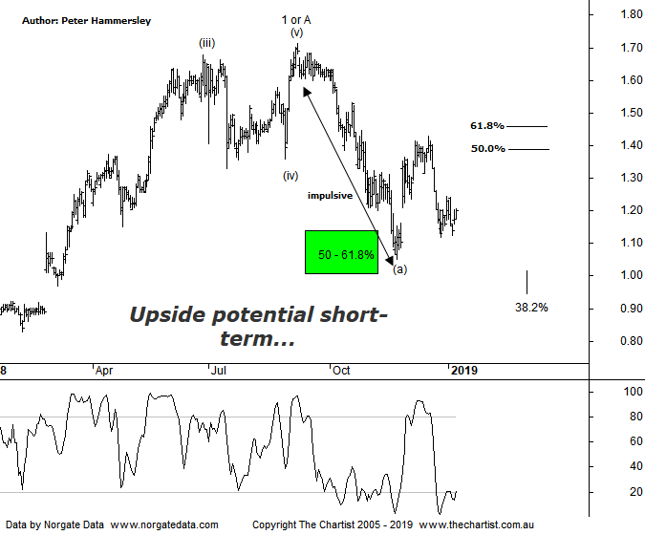

Bottom Line
8/1:
Daily Trend: Up
WeeklyTrend: Down
Monthly Trend: Down
Support Levels: $1.05 - $1.00 / $0.95 - $0.88
Resistance Levels: $1.71 / $1.935
Video Analysis
Watch Video Analysis Here
Technical Discussion
Accent Group Limited (AX1), formerly RCG Corporation Limited, is an investment holding company. The Company owns and operates a range of footwear and apparel businesses in the performance and active lifestyle sectors. It operates through four sections: The Athlete's Foot, a franchisor and retailer of general sports footwear. The Company’s brand includes Athlete’s Foot CAT, Dr. Martens, Merrell, Palladium, Platypus, Podium sports, saucony, Skechers, Sperry, Stance, Hype dc, SHUBAR, Timberland, and VANS. For the year ending the 01st July 2018 revenues increased 11% to A$703.2M. Net income increased 51% to A$44M. Revenues reflect the increase in sales to customers of 11% to A$675.6M, other revenue increased 19% to A$3.1M. Net income benefited from the Impairment of HYPE DC brand name which decreased from A$9.7M to zero. Broker consensus is “Buy”. The dividend yield is 5.7%.
Reasons to remain bullish longer term (caution short-term):
→ Online sales growth has been exceptionally strong due to continued investment.
→ Upside risk to guidance.
→ The company’s margin dollar growth is a head of sales growth implying reducing discounts has been successful.
→ Competition from Amazon hasn’t had a limited impact.
→ Exceptionally strong longer-term uptrend intact.
→ Attractive dividend yield.
This is the first time we’ve reviewed AX1 although rather than delve into the weekly chart (which lacks symmetry) we’ll get straight into the smaller degree patterns on the daily. The big positive is that from June 2017 strong impulsive price action kicked in which culminated at the high of wave-1 or-A in September last year. Like many of the stocks with cover though, the subsequent retracement hasn’t unfolded as a corrective pattern. Yes, price has hit the 50% - 61.8% retracement zone of the prior leg higher but within a very short timeframe. Normally a retracement will take at least 38.2% of the time taken by the prior leg which as can be seen on this chart hasn’t come anywhere near to being achieved. Not that we are necessarily looking for strength running into that time projection but it’s something to focus on as the patterns progress. All things being equal, we’d expect the prior pivot low to complete the first stage of a larger corrective pattern. Should the current rally continue price should head up into the 50% - 61.8% retracement zone as annotated as a minimum. A push through the upper boundary of that target opens the door for a continuation up toward the recent pivot high circa $1.70 although it’s difficult to be any more bullish at this stage. A quick look at the weekly chart (not shown) shows that Type-A bearish divergence has been an issue recently with price making a higher high whilst our oscillator has failed to confirm that strength by making a lower high. However, although this is likely the reason for the retracement that commenced in early September last year, it’s no longer a headwind as our indicator has hit the oversold position. For now, we’ll just focus on the immediate target area either side of $1.40 and look for the reaction in that zone - assuming it’s going to be tagged.
Trading Strategy
As mentioned above, we’d normally be looking for a buying opportunity when price rejects from the typical retracement zone, though not when a straight-line leg lower unfolds as it has here. The bottom line is, symmetry is lacking meaning it’s best to stand aside until it returns. If you are looking for short setups, an opportunity could arise around $1.40 following signs of clear rejection. Either way, we’ll stand aside until the smaller degree patterns become clearer.

