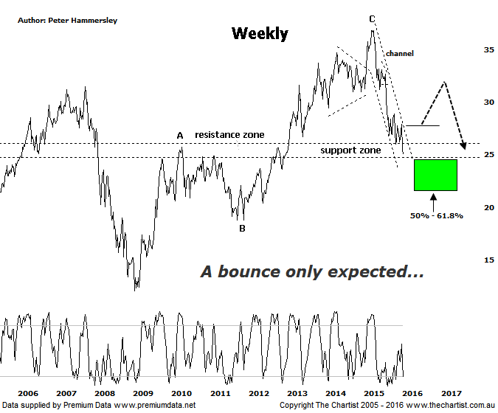

Bottom Line
12/1:
Daily Trend: Down
Weekly Trend: Down
Monthly Trend: Down
Support Levels: $25.01 - $24.50 / $21.54
Resistance Levels: $29.17 / $31.13 / $32.57
Video Analysis
Watch Video Analysis Here
Technical Discussion
ANZ is one of Australia's "Big 4" offering a range of banking and financial products to retail, corporate and institutional clients. Whilst ANZ is best known in Australia and New Zealand, it has a significant business in Asia. In July 2014 the company completed the sale of ANZ Trustees Ltd to Equity Trustees Ltd. For the year ending the 30th of September 2015 interest income increased 3% to A$30.53B. Net interest income after loan loss provision increased 5% to A$13.44B. Net income applicable to shareholders increased 3% to A$7.49B. Broker/Analyst consensus is currently “Hold”. The company pays a dividend of 7.2%.
Reasons to be cautious (bounce likely short term):
→ ANZ is not the preferred exposure to the sector.
→ Asia slowing could be problematic, especially if U.S rates rise.
→ Ongoing capital management is expected.
→ Trading profits will be adversely affected during any sustained correction.
→ Recent weakness may be overdone short term, but larger degree patterns suggest lower prices will come.
Price continues to head lower which of course means that the dividend yield is heading higher, now just sitting above 7%. If the major players were of the opinion that the dividend was sustainable one would assume that some buying would be taking place though this clearly isn’t the situation. Some brokers have amended their view of the yield and stated that it will more than likely be cut which really wouldn’t come as a great surprise. Either way, there is no reason to be buying any of the banks solely on the back of the dividend alone with other factors needing to be taken into consideration. For us that means looking at the technical picture by delving into with the weekly chart again. This larger time frame continues to show the most clarity in almost all of the banks. The interesting aspect of this chart is that the typical retracement zone of the whole leg higher that commenced in 2009 is now within a whisker of being tagged. In normal circumstances we’d now be looking for signs of strength and therefore a buying opportunity. A couple of things to consider though. First of all, we always need to see symmetry both in terms of price and time with the latter coming nowhere near to fulfilling our requirements. A corrective pattern should take at least 38.2% of the time taken by the prior trend. ANZ has barely achieved 15% which automatically advocates caution. Secondly, the movement down from the April 2015 high does have an impulsive look about it which again suggests a corrective phase is still only in its early stages. A larger consolidation pattern doesn’t look likely here with a zigzag probably being the correction of choice although we’ll take a closer look at this during this evenings video.
Trading Strategy
ANZ isn’t the worst performer of the big four with NAB taking that spot although it hasn’t performed anywhere near as well as CBA & WBC (which we took a look at yesterday). In fact, Westpac is sitting well above its zone of support which is something that can’t be said here. That said, there is no reason to short this stock now. First of all the typical retracement zone has just about been tagged which means we are now in a position to see a bounce. This is required if we’re to see a symmetrical 3-wave movement down into the 50% - 6 1.8% retracement zone, which would be the ideal situation. For now, it’s best to stay clear, especially if you’re a longer term trader or investor.

