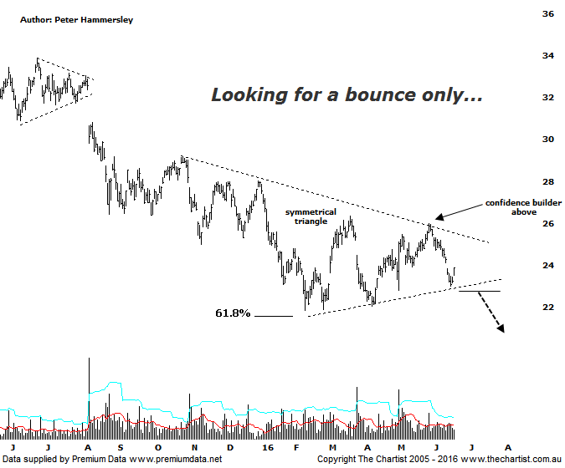

Bottom Line
20/6:
Daily Trend: Down
Weekly Trend: Down
Monthly Trend: Down
Support Levels: $21.86 - 21.54 / $19.95 - $17.63
Resistance Levels: $26.35 / $29.17 / $31.13
Video Analysis
Watch Video Analysis Here
Technical Discussion
ANZ is one of Australia's "Big 4" offering a range of banking and financial products to retail, corporate and institutional clients. Whilst ANZ is best known in Australia and New Zealand, it has a significant business in Asia. In July 2014 the company completed the sale of ANZ Trustees Ltd to Equity Trustees Ltd. For the year ending the 30th of September 2015 interest income increased 3% to A$30.53B. Net interest income after loan loss provision increased 5% to A$13.44B. Net income applicable to shareholders increased 3% to A$7.49B. Broker/Analyst consensus is currently “Hold”. The company pays a dividend of 7.8%.
Reasons to be cautious:
→ ANZ is not the preferred exposure to the sector.
→ Asia slowing could be problematic, especially if U.S rates rise.
→ Ongoing capital management is expected.
→ Trading profits will be adversely affected during any sustained correction.
→ Recent weakness may be overdone short term, but larger degree patterns suggest lower prices will come.

A large rally took place in the Banking Sector today which helped the XJO gain some lost ground. However, one thing is for sure, the XXJ isn’t looking particularly bullish which of course has been our stance for many months now. That’s not to say the bounce witnessed today can’t continue as it certainly can but the likes of ANZ are going to have to prove themselves before getting a vote of confidence from us. In fact, the most pertinent pattern on this particular chart is the large symmetrical triangle that commenced back in October 2015. It isn’t the textbook Elliott variety but it needs watching carefully as it has been containing price very nicely indeed. A couple of days ago price rebounded from the lower trend line of the structure which offers the potential to continue toward the upper boundary over the next few weeks. The only fly in the ointment could be the Brexit vote although this is true of the broader market in general and at that this stage is a complete unknown. As a stand-alone pattern though, we need to be watching the lower trend line as a push beneath would portend another leg South. Should this prove to be the path of least resistance then it’s difficult to envisage the XJO (refer Friday’s review) managing to avoid the deeper retracement discussed on Friday. In other words, we need to be a little sceptical in regard to any forthcoming strength as it could well be short- lived and prove to be nothing more than a dead cat bounce. Indeed, it would take an impulsive movement up through $26.00 to start thinking in terms of something much more bullish unfolding. Not impossible, though not looking likely when perusing the patterns on this daily chart.
Trading Strategy
The bearish divergence mentioned last time is no longer an issue with our oscillator starting to move higher out of the oversold position. This doesn’t particularly provide a back wind but it could allow price to bounce over the short-term. However, even if the upper boundary of the triangle is tagged over the coming weeks it doesn’t offer enough in the way of risk/reward to want to be involved from our perspective. In fact, a choppy corrective pattern higher toward the upper trend line would potentially offer a shorting opportunity although that’s something to reconsider further down the line. Either way, for the moment our stance remains unchanged in that we really don’t want to be involved in any of the big four banks at this juncture.

Disclosure: Nick Radge holds

