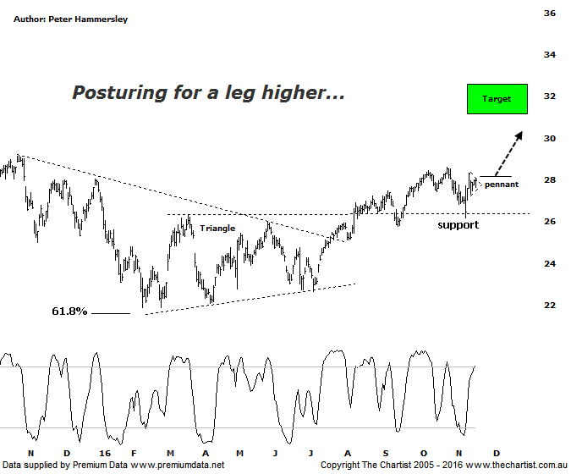

Bottom Line
17/11:
Daily Trend: Up
Weekly Trend: Up
Monthly Trend: Up
Support Levels: $25.78 / $21.86
Resistance Levels: $29.17 - $29.56 / $31.13 - $32.57
Video Analysis
Watch Video Analysis Here
Technical Discussion
ANZ is one of Australia's "Big 4" offering a range of banking and financial products to retail, corporate and institutional clients. Whilst ANZ is best known in Australia and New Zealand, it has a significant business in Asia. In July 2014 the company completed the sale of ANZ Trustees Ltd to Equity Trustees Ltd. For the six months ending the 31st of March 2016 interest income decreased 2% to A$15.09B. Net interest income after loan loss provision increased less than 1% to A$6.66B. Net income applicable to common shareholders decreased 22% to A$2.74B. Broker/Analyst consensus is currently “Hold”. The company pays a dividend of 5.7%.
Reasons to be cautious:
→ Restructuring risks remain.
→ There are still question marks regarding the dividend being maintainable.
→ Margins could decline by around two basis points due low-yielding exposures.
→ Management focusing on returns as opposed to growth.
→ Asia slowing could be problematic, especially if U.S rates rise.
→ Ongoing capital management is expected, albeit further down the track.
It’s worth mentioning that we also cover the Banking Sector (XXJ) this evening which goes into more detail regarding the pros and cons of the sector. The main positive in most of the banks is that price has either broken through resistance (as in this case) or is posturing to do so. Over more recent times ANZ has been the pick of the bunch with a positive reaction witnessed following results. The interesting aspect of this chart is that old resistance, which is now acting as new support was revisited during U.S election day. As with most stocks, intraday weakness was bought up resulting in a close off the session’s lows. Not that it’s been a strong impulsive movement higher over the past week although price continues to remain resilient. Sooner rather than later though price is going to need to break higher to keep the tentative bullish case alive. A push above Friday’s high at $28.34 would go some way in regard to doing just that. One thing is for sure, a corrective pattern higher has been unfolding from the significant lows made in February of this year which comes down to the choppy and messy price action that’s been taking hold. However, there is still room for higher levels, even regarding a countertrend movement higher only. The typical retracement zone of the whole leg down from the all-time highs sits between $29.56 - $31.37 with a strong chance that those higher levels can be attained. A push above the upper boundary of that target would open the door for something more bullish to unfold, with the measured move out of the triangle aligning with $32.00.
Trading Strategy
Zooming right into the recent price action shows that a small pennant has been forming over the past few days which provides a low risk entry for the nimbler trader. The strategy is to buy following a push through the upper boundary of the pattern meaning a break above today’s high at $28.07 would be reason to jump on. The initial stop should be placed just beneath last Thursday’s low at $27.01. A trailing stop will need to be used to manage the position although a rotation up toward the typical retracement zone, and possibly the measured move out of the triangle around $32.00 would be our expectation. We are going to make a formal recommendation this evening.

Disclosure: Nick Radge holds

