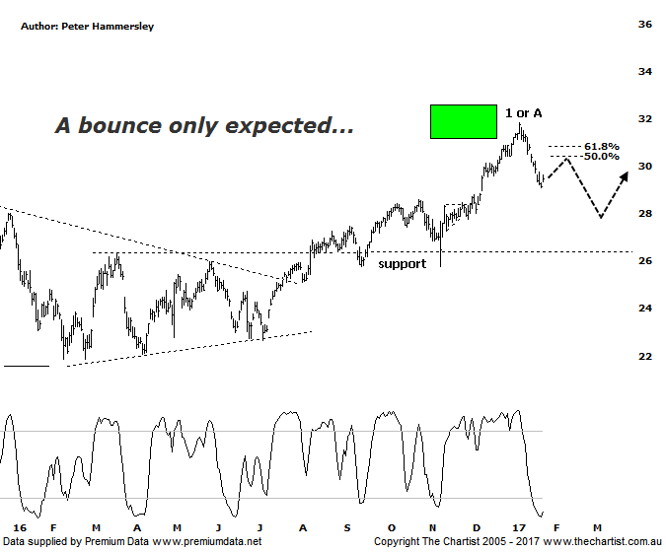

Bottom Line
25/1:
Daily Trend: Down
Weekly Trend: Up
Monthly Trend: Up
Support Levels: $28.59 - $28.00 / $27.25 - $26.16
Resistance Levels: $31.84 / $37.25
Video Analysis
Watch Video Analysis Here
Technical Discussion
ANZ is one of Australia's "Big 4" offering a range of banking and financial products to retail, corporate and institutional clients. Whilst ANZ is best known in Australia and New Zealand, it has a significant business in Asia. In July 2014, the company completed the sale of ANZ Trustees Ltd to Equity Trustees Ltd. For the six months ending the 31st of March 2016 interest income decreased 2% to A$15.09B. Net interest income after loan loss provision increased less than 1% to A$6.66B. Net income applicable to common shareholders decreased 22% to A$2.74B. Broker/Analyst consensus is currently “Hold”. The company pays a dividend of 5.5%.
Reasons to be more optimistic:
→ Higher bond yields will reduce pressure on net interest margins.
→ Improved credit quality and steady revenue trends.
→ Restructuring remains a focus.
→ The mortgage pricing war appears to have eased with discounting reduced.
→ Management focusing on returns as opposed to growth.
→ Headwinds regarding Australian banks have recently eased.
We’ve been more bullish on the banks over the past few months and there’s no doubt that a decent bounce has been witnessed since mid-last year. In the case of ANZ we were looking for our target zone up around $32.00 to be tagged, so in that regard we couldn’t have asked for anything more. However, that target was our minimum expectation with the ideal situation being to break through the upper boundary with a degree of attitude. This would have opened the door for something much more bullish longer term to unfold. The problem now is that price rejected hard from our target area with impulsive price action taking the stock lower, albeit over the short-term. This now suggests that a deeper retracement is going to unfold, potentially taking price down toward $27.25 - $26.16 within a larger countertrend movement. First of all though, a bounce is more than feasible with the typical retracement zone of the prior leg down likely going to be the next port of call, although this is assuming that yesterday’s low is not going to be penetrated over the coming days which is by no means a foregone conclusion. The minor degree patterns taking a turn for the worse isn’t ideal although a slightly deeper retracement is neither here nor there in the bigger scheme of things. It just means a little more patience is going to be required before strong impulsive price action resumes. For the moment, we’ll concentrate on how any subsequent bounce unfolds and whether it’s impulsive or corrective in nature although at this stage the latter seems more likely.
Trading Strategy
“…We currently hold long positions at $28.08 but although price is heading in our favour, we’ll leave our initial stop in place for the moment to allow room to breathe. We’ll also continue to run with a trailing stop as opposed to a set target, although as mentioned last time there is scope to head up toward the measured move out of the triangle around $32.00…”. We’ve allowed the trade room to breathe although the straight-line decline is reason for concern. One thing is for sure, if a corrective pattern takes price into the typical retracement zone slightly above current levels we’ll be looking to take profits and await a better, and longer term buying opportunity at lower levels. If you aren’t already involved it’s best to continue to stand aside although a shorting opportunity could present itself just above $30.00 in a week or two’s time for the more aggressive trader.

Disclosure: Nick Radge holds

