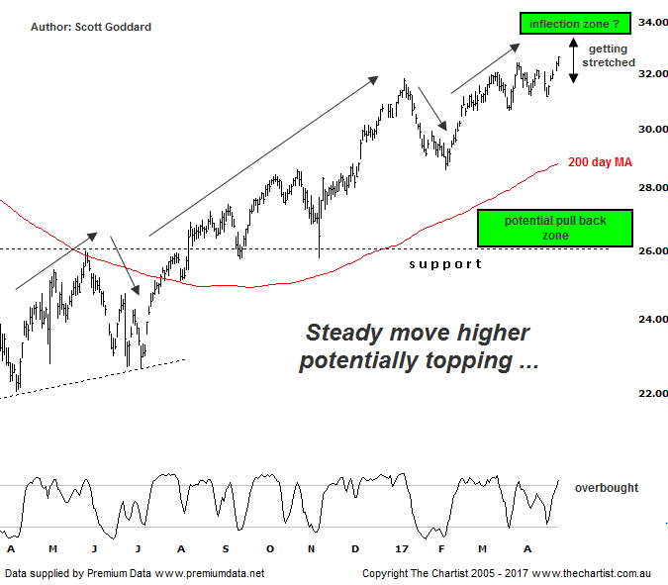

Bottom Line
27/4:
Daily Trend: Up
Weekly Trend: Up
Monthly Trend: Up
Support Levels: $30.65 / $28.59 - $28.00 / $25.78
Resistance Levels: $35.07 / $37.25
Video Analysis
Watch Video Analysis Here
Technical Discussion
ANZ is one of Australia's "Big 4" offering a range of banking and financial products to retail, corporate and institutional clients. Whilst ANZ is best known in Australia and New Zealand, it has a significant business in Asia. In July 2014, the company completed the sale of ANZ Trustees Ltd to Equity Trustees Ltd. For the year ending the 30th of September 2016 interest income decreased 2% to A$29.95B. Net interest income after loan loss provision decreased 2% to A$13.17B. Net income applicable to shareholders decreased 24% to A$5.71B. Broker/Analyst consensus is currently “Hold”. The company pays a dividend of 5.0%.
Reasons to be more optimistic:
→ Earnings per share stronger than its peers.
→ Higher bond yields will reduce pressure on net interest margins.
→ Improved credit quality and steady revenue trends.
→ Restructuring remains a focus.
→ The mortgage pricing war appears to have eased with discounting reduced.
→ Management focusing on returns as opposed to growth.
→ Headwinds regarding Australian banks have recently eased.
ANZ is not really able to be labelled within the traditional waves of Elliott Wave analysis, yet we have ironed out some noise on our chart tonight to reveal scope for a 5-wave move to be highly evolved off the early 2016 lows. It does set the scene for this 12 month cycle to be close to completion though, especially with price action having become labored, crossing over and choppy since mid March. There is still scope for a further 3-5% in gains over the coming weeks that could see price stretch up towards $34.00, yet we wouldn't be surprised to see it fall short before embarking on a short to medium term unwinding process. If this projection does come to fruition, then the first port of call for price to head to would logically be the 200 day moving average circa $29.00 which is also a minor area of support / resistance. Yet the price point we will be more focused on will be the stronger support line circa $26.00. A successful retest of this important line in the sand would certainly have us sitting up and taking notice and in fact would be a prime area for us to consider taking on some early positions if buyer support down here proved to be robust enough. Happy to play the waiting game with bank stocks at the moment.
Trading Strategy
As mentioned the push higher has been a little choppy overall yet if we iron out some noise on our chart, there is certainly scope for the run higher off the 2016 lows to be drawing to a close very soon as stated. As such we would prefer to just continue to sit tight on this from a trading perspective, as we have also recommended with NAB in LAST NIGHT's REVIEW. If price does trigger a decent breather over the coming weeks, then the $26.00 support line will certainly have our interest from a trading perspective, once the aforementioned pull back finally runs its course.

Disclosure: Nick Radge holds

