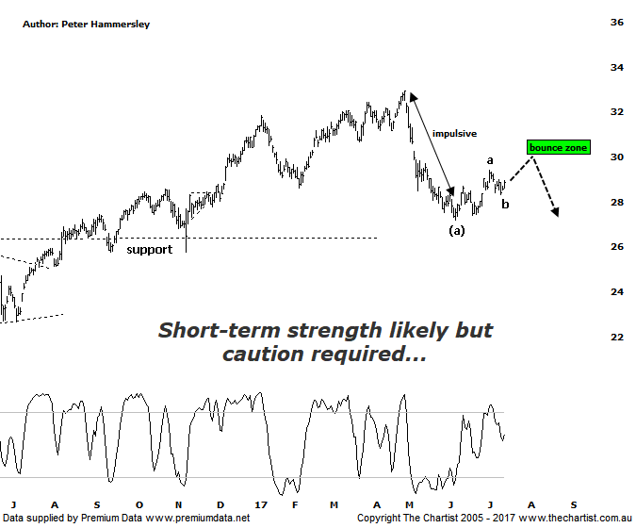

Bottom Line
14/7:
Daily Trend: Neutral
Weekly Trend: Down
Monthly Trend: Down
Support Levels: $27.18 / $26.16 / $25.78 / $24.74
Resistance Levels: $30.06 - $30.74 / $32.95
Video Analysis
Watch Video Analysis Here
Technical Discussion
ANZ is one of Australia's "Big 4" offering a range of banking and financial products to retail, corporate and institutional clients. Whilst ANZ is best known in Australia and New Zealand, it has a significant business in Asia. In July 2014, the company completed the sale of ANZ Trustees Ltd to Equity Trustees Ltd. For the year ending the 30th of September 2016 interest income decreased 2% to A$29.95B. Net interest income after loan loss provision decreased 2% to A$13.17B. Net income applicable to shareholders decreased 24% to A$5.71B. Broker/Analyst consensus is currently “Hold”. The company pays a dividend of 5.6%.
Reasons to be optimistic longer term (short to medium term weakness expected):
→ New bank levy a concern for the Big 4.
→ Earnings per share stronger than its peers.
→ Higher bond yields will reduce pressure on net interest margins.
→ Improved credit quality and steady revenue trends.
→ Restructuring remains a focus.
→ The mortgage pricing war appears to have eased with discounting reduced.
→ Management focusing on returns as opposed to growth
The main problem with all the banks over the past few weeks has been the impulsive movement down to the recent pivot low. It’s evident on this chart of ANZ with a straight-line decline unfolding off the early May high. At this stage of the trend, this should not complete the whole corrective pattern which keeps the door firmly open for lower prices, albeit likely following short-term strength. There is no high probability wave count available on the larger degree patterns so we’ll concentrate on the more recent price action. It’s likely that the prior decline completes intermediate degree wave-(a) with the subsequent bounce well underway. Minor degree waves-a &-b are likely in position with the final probe higher at this degree of trend within wave-c already unfolding. This should take price up into the typical retracement zone as annotated although rejection at those higher levels would portend another decent leg South - very similar in length to wave-(a) which was a retracement of just over 17.0 %. In other words, we must be sceptical regarding the recent rally as all things being equal it shouldn’t have too far to run before coming to an abrupt halt. The much talked about bearish divergence over recent months in the banks, and the Banking sector has unwound which has allowed price to turnaround although this is being viewed as one less headwind as opposed to being a bullish proposition. It would take a push above the 61.8% retracement level at $30.75 before thinking in terms of avoiding a deeper retracement. Not impossible, but this isn’t looking likely considering how the smaller degree patterns have been unfolding.
Trading Strategy
We’ve seen no reason to want to be in the banks for some time now and although there is potential for higher prices over the short-term, there isn’t enough upside to want to be involved. In fact, a push back up into the typical retracement zone followed by signs of weakness would present a shorting opportunity as this should be followed by another decent leg South. Broader market conditions permitting, we’ll be looking for a setup over the coming weeks although for the moment there’s still every reason to remain out of the sector.

Disclosure: Nick Radge holds

