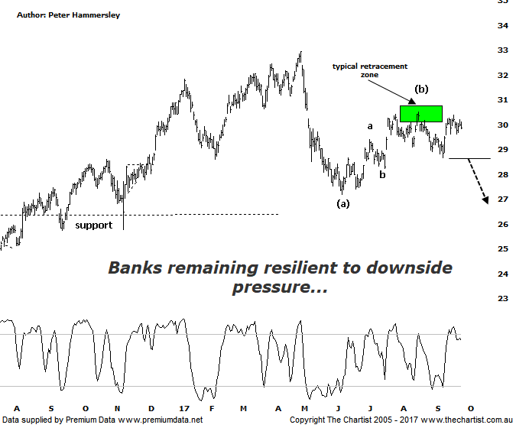

Bottom Line
26/9:
Daily Trend: Neutral
Weekly Trend: Up
Monthly Trend: Neutral
Support Levels: $27.18 / $26.16 / $25.78 / $24.74
Resistance Levels: $30.06 - $30.75 / $32.95
Video Analysis
Watch Video Analysis Here
Technical Discussion
ANZ is one of Australia's "Big 4" offering a range of banking and financial products to retail, corporate and institutional clients. Whilst ANZ is best known in Australia and New Zealand, it has a significant business in Asia. In July 2014, the company completed the sale of ANZ Trustees Ltd to Equity Trustees Ltd. For the six months ending the 3st of March 2017 interest income decreased 4% to A$14.43B. Net interest income after loan loss provision increased less than 1% to A$6.7B. Net income increased 6% to A$2.91B. Broker/Analyst consensus is currently “Hold”. The company pays a dividend of 5.3%.
Reasons to be optimistic longer term (caution short-term):
→ Management delivering on cost reductions, credit quality and capital generation.
→ Buybacks for FY18 could be as high as $2.5bn.
→ Slow third-quarter asset sales and revenue weakness.
→ Poor underlying revenue growth and weaker markets income.
→ Earnings per share stronger than its peers.
→ Higher bond yields will reduce pressure on net interest margins.
→ Improved credit quality and steady revenue trends.
→ Restructuring remains a focus.
→ The mortgage pricing war appears to have eased with discounting reduced.
It would be fair to say that the big four banks are remaining surprisingly resilient despite being in a position to see another leg South. Having hit the typical retracement zone last time, another leg lower similar in length to the one seen from the high made in early May was more than feasible which offered a decline of around 17%. If this was going to transpire though, an impulsive leg down needed to follow, and despite initial weakness this really hasn’t transpired. In fact, price is now looking to head up through the minor line of resistance slightly above current levels. A push up through $30.52 would go a long way regarding avoiding the deeper retracement. It would take an immediate push down through the prior pivot low at $28.67 to suggest our wanted zigzag is going to take price down into the typical retracement zone sitting between $27.25 - $26.16. The more price postures in this region the greater the chance that the next move is going to be up, although this would likely only be bullish over the short-term. The main problem here is the impulsive nature of movement down to wave-(a) which should not complete the whole corrective pattern. As such, even a push up through the high of wave-(b) will only imply a larger flat pattern or triangle is going to form which means the early May high is unlikely to be overcome at the first attempt. Looking at the weekly chart (not shown) reiterates our stance that a larger corrective pattern still needs to evolve before the strong prior uptrend resumes. If that means seeing a shallow correction as opposed to the typical zigzag then so be it.
Trading Strategy
We are holding short positions from $29.09 although this was a very low risk trade with our initial stop set at $30.76 which is where it remains. There’s no point tightening the trailing stop now just for the sake of it as we always need to have a logical level to focus on which proves the analysis incorrect. Just remember, even if price breaks higher immediately there’s still reason for scepticism which will remain the case unless the high made in May around $33.00 is overcome in impulsive fashion. Not impossible, but a push up through that level isn’t looking likely without first seeing further posturing in this general region which should take several months.

Disclosure: Nick Radge holds

