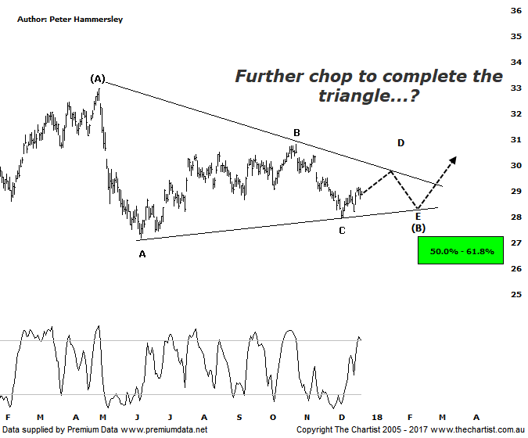

Bottom Line
22/12:
Daily Trend: Up
Weekly Trend: Down
Monthly Trend: Down
Support Levels: $27.18 / $26.16 / $25.78 / $24.74
Resistance Levels: $30.06 - $30.80 / $32.95
Video Analysis
Watch Video Analysis Here
Technical Discussion
ANZ is one of Australia's "Big 4" offering a range of banking and financial products to retail, corporate and institutional clients. Whilst ANZ is best known in Australia and New Zealand, it has a significant business in Asia. In July 2014, the company completed the sale of ANZ Trustees Ltd to Equity Trustees Ltd. For the year ending the 30th of September 2017, interest income decreased 3% to A$29.12B. Net interest income after loan loss provision increased 4% to A$13.67B. Net income increased 12% to A$6.41B. Net interest income after loan loss provision highlights the Australia section increase of 3% to A$7.49B and the New Zealand section increase of 5% to A$2.44B. Broker/Analyst consensus is currently “Hold”. The company pays a dividend of 5.5%.
Reasons to be optimistic longer term (caution short-term):
→ Management delivering on cost reductions, credit quality and capital generation.
→ Buybacks for FY18 could be as high as $2.5bn.
→ Slow third-quarter asset sales and revenue weakness.
→ Poor underlying revenue growth and weaker markets income.
→ Earnings per share stronger than its peers.
→ Higher bond yields will reduce pressure on net interest margins.
→ Improved credit quality and steady revenue trends.
→ Restructuring remains a focus.
→ The mortgage pricing war appears to have eased with discounting reduced.
It would be stating the obvious to say we haven’t been great fans of the banks over the past few months although in many ways they have continued to be resilient. Don’t get me wrong, they have performed poorly but it could be that price needs to consolidate over the coming weeks as opposed to getting another impulsive leg South. The patterns here for ANZ offer such a possibility. I’ve tentatively put forward a symmetrical triangle, which if correct suggests strength over the short-term followed by one final brief probe lower to complete the pattern. This would be extremely bullish should it transpire as it would mean larger degree wave-(B) is going to be locked in early next year which would set the stage for a strong leg higher. The prerequisite is that the low of wave-C at $27.93 isn’t penetrated during any subsequent weakness. If it is, then the chance of seeing a more bearish zigzag increases significantly. This would allow for a rotation down into the typical retracement zone as shown as a minimum although the wave equality projection sits slightly lower at $25.03 providing some confluence. All we can do for now is concentrate on the lower trend line of the triangle as this is likely to be the trigger for a deeper retracement if breached. Some brokers are suggesting further weakness in the big four banks, pointing to the Royal commission and the lack of growth moving forward as a potential downside catalyst. Who knows, they could be correct although let’s not forget that the market is forward-looking, so these potential negatives will already be factored into prices. We’ll continue to stick to the patterns and let them dictate where price is likely to move from here.
Trading Strategy
Whether the triangle continues to form are not, there is still no compelling reason to be a buyer of the banks at this stage. That said, we reviewed BEN yesterday which shows a corrective pattern that appears to be further advanced. In other words, if the banks are to head higher then the company could show the big four the way forward. BOQ is another one to keep a close eye on although we’ll take a closer look at the stock over next week or so for an opportunity. One thing is for sure, if the broader market is to trend higher with some vigour next year, then it’s going to need the help of the banks otherwise the XJO is going to be trying to trend with a heavy weight around its neck.

Disclosure: Nick Radge holds

