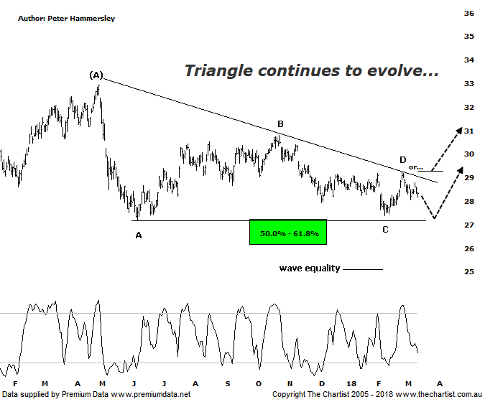

Bottom Line
14/3:
Daily Trend: Down
Weekly Trend: Down
Monthly Trend: Down
Support Levels: $27.18 / $26.16 / $25.78 / $24.74
Resistance Levels: $30.06 - $30.80 / $32.95
Video Analysis
Watch Video Analysis Here
Technical Discussion
ANZ is one of Australia's "Big 4" offering a range of banking and financial products to retail, corporate and institutional clients. Whilst ANZ is best known in Australia and New Zealand, it has a significant business in Asia. In July 2014, the company completed the sale of ANZ Trustees Ltd to Equity Trustees Ltd. For the year ending the 30th of September 2017, interest income decreased 3% to A$29.12B. Net interest income after loan loss provision increased 4% to A$13.67B. Net income increased 12% to A$6.41B. Net interest income after loan loss provision highlights the Australia section increase of 3% to A$7.49B and the New Zealand section increase of 5% to A$2.44B. Broker/Analyst consensus is currently “Hold”. The company pays a dividend of 5.6%.
Reasons to be optimistic longer term (caution short-term):
→ Management delivering on cost reductions, credit quality and capital generation.
→ Buybacks for FY18 could be as high as $2.5bn.
→ Slow third-quarter asset sales and revenue weakness.
→ Poor underlying revenue growth and weaker markets income.
→ Earnings per share stronger than its peers.
→ Higher bond yields will reduce pressure on net interest margins.
→ Improved credit quality and steady revenue trends.
→ Restructuring remains a focus.
→ The mortgage pricing war appears to have eased with discounting reduced.
Although we haven’t been big fans of the big four banks over the past few months most have been embarking on consolidation phases as opposed to undergoing significant weakness. This always keeps the door open to see an upside breakout although like any pattern it needs to prove itself before getting overly confident. That said, last time we were looking for a probe back up toward the upper boundary of the descending triangle before seeing one final probe down toward the lower trend line which is precisely what’s unfolded. Yes, there is scope to head down to just above $27.00 over next few weeks although ultimately the next major move must be to the upside for the pattern to trigger. Should this be the way forward, we can start thinking in terms of a multi-month trend higher unfolding with the measured move out of the triangle allowing for a push back up toward the April 2017 high circa $33.00 - $34.00 which would be a move worth being involved with. Although we don’t always need a bullish fundamental trigger for strength this would be the ideal situation. The problem is, most brokers and analysts are finding it difficult to see where future growth is going to stem from. Also, although the dividend yield is enticing, rising interest rates are going to make this less attractive. In other words, it appears that fundamental headwinds are in place which is less than ideal. It doesn’t detract from the upside potential from a pure technical perspective but ideally we’d like the two to align which isn’t the case here. All that said, we are predominantly technical analysts meaning our focus of attention must be on the descending triangle over the coming weeks.
Trading Strategy
Our last trade in any of the the banks was BOQ which didn’t go according to plan with a small loss being the end result. Not that this has any influence on a potential trade in the big four banks, but we must await a solid set-up before getting involved. In the case of ANZ this means waiting for price to retest the lower boundary of the triangle as a minimum although initiating positions down at those lower levels, even following strength would be aggressive. The more conservative strategy is to wait until the upper trend line of the triangle is overcome as this would provide much more confidence regarding a decent trend higher unfolding. One for the watchlist if you want exposure to the Banking sector although no reason to jump in immediately.

Disclosure: Nick Radge holds

