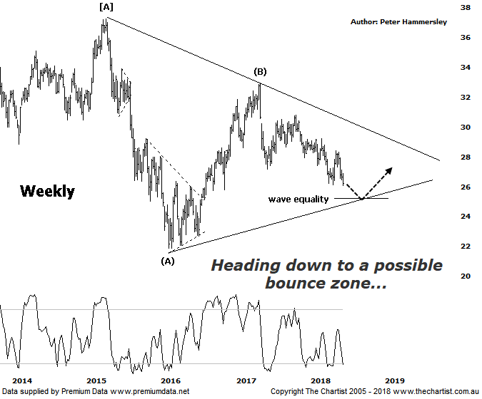

Bottom Line
14/6:
Daily Trend: Down
Weekly Trend: Down
Monthly Trend: Down
Support Levels: $25.03 - $24.54 / $21.54 / $21.86
Resistance Levels: $30.06 - $30.80 / $32.95
Video Analysis
Watch Video Analysis Here
Technical Discussion
ANZ is one of Australia's "Big 4" offering a range of banking and financial products to retail, corporate and institutional clients. Whilst ANZ is best known in Australia and New Zealand, it has a significant business in Asia. In July 2014, the company completed the sale of ANZ Trustees Ltd to Equity Trustees Ltd. For the year ending the 30th of September 2017, interest income decreased 3% to A$29.12B. Net interest income after loan loss provision increased 4% to A$13.67B. Net income increased 12% to A$6.41B. Net interest income after loan loss provision highlights the Australia section increase of 3% to A$7.49B and the New Zealand section increase of 5% to A$2.44B. Broker/Analyst consensus is currently “Hold”. The company pays a dividend of 6.1%.
Reasons to be cautious:
→ A high degree of uncertainty due to the Royal commission.
→ Management delivering on cost reductions, credit quality and capital generation.
→ Buybacks for FY18 could be as high as $2.5bn.
→ Slow third-quarter asset sales and revenue weakness.
→ Poor underlying revenue growth and weaker markets income.
→ Earnings per share stronger than its peers.
→ Higher bond yields will reduce pressure on net interest margins.
→ Improved credit quality and steady revenue trends.
→ Restructuring remains a focus.
→ The mortgage pricing war appears to have eased with discounting reduced.
To say that sentiment is negative for the big four banks would be an understatement with many headwinds making investors look elsewhere. The Royal commission outcome is an unknown and is the main reason for continued nervousness although there are other factors to take into consideration. The housing cycle is one, with most analysts and brokers suggesting that it is softening. High levels of household debt coupled with high house prices will likely trigger a downturn at some juncture although it continues to remain resilient for the time being. The mortgage markets are also suffering due to more arduous capital rules, credit rationing and tighter lending standards. This opens the door for lower returns for the banks. That’s the bad news. The better news is that most of these factors are likely already factored into price meaning the likes of ANZ are unlikely to fall over the edge of a cliff, albeit there is still downside risk. During our last review we were looking for a probe down to the wave equality projection as annotated at $25.00 which is still our expectation. There could be a bounce during the interim due to bullish divergence on this weekly chart although price would need to head higher immediately for it to trigger. In other words, it’s something to watch only at this stage as opposed to advocating a turnaround right here and now. From an Elliott perspective a push down to the aforementioned target area followed by strength would increase the chances of witnessing a large triangle. If this is to be the way forward it’s going to take several months, if not years before completing although there will be decent trends within such a large pattern.
Trading Strategy
“…For those looking for the bigger buying opportunity it now seems like much more time is going to be required before a sustainable uptrend kicks into gear…” Nothing changes from a trading point of view with no opportunities available at this time. However, there is scope for a decent bounce to materialise from the wave equality projection which isn’t too far beneath current levels. Our stance has been to stand aside from the banks over the past few months, especially as there have been far better opportunities elsewhere. Nothing changes in that regard.

