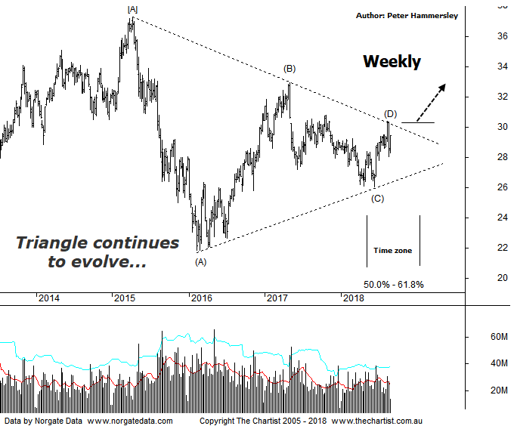

Bottom Line
29/8:
Daily Trend: Neutral
Weekly Trend: Up
Monthly Trend: Up
Support Levels: $26.07 - $24.54 / $21.54 / $21.86
Resistance Levels: $30.06 - $30.80 / $32.95
Video Analysis
Watch Video Analysis Here
Technical Discussion
ANZ is one of Australia's "Big 4" offering a range of banking and financial products to retail, corporate and institutional clients. Whilst ANZ is best known in Australia and New Zealand, it has a significant business in Asia. In July 2014, the company completed the sale of ANZ Trustees Ltd to Equity Trustees Ltd. For the year ending the 30th of September 2017, interest income decreased 3% to A$29.12B. Net interest income after loan loss provision increased 4% to A$13.67B. Net income increased 12% to A$6.41B. Net interest income after loan loss provision highlights the Australia section increase of 3% to A$7.49B and the New Zealand section increase of 5% to A$2.44B. Broker/Analyst consensus is currently “Hold”. The company pays a dividend of 5.6%.
Reasons to be cautious:
→ A sector leading capital position in its third-quarter update.
→ Scope for additional buybacks in FY19/20.
→ If current conditions persist, credit quality should continue to improve.
→ A high degree of uncertainty due to the Royal commission.
→ Management delivering on cost reductions, credit quality and capital generation.
→ Earnings per share stronger than its peers.
→ Higher bond yields will reduce pressure on net interest margins.
→ Improved credit quality and steady revenue trends.
→ Restructuring remains a focus.
→ The mortgage pricing war appears to have eased with discounting reduced.
With all the big four banks, large consolidation patterns have been dictating the charts recently with nothing changing in that regard. In fact, the patterns continue to unfold in textbook fashion. We were looking for a push toward the upper boundary of the pattern following our last review, to be followed by one final probe lower. So far so good. One thing to bear in mind is that with symmetrical triangles, wave-(e) is often truncated meaning it fails to hit the lower boundary of the pattern. This is perfectly acceptable and is something that occurs regularly. Last week’s low could theoretically complete the final probe down if price gets on with the job immediately. Either way, the upper trend line needs to be overcome before the pattern triggers which needs to be our focal point for the time being. We are still counting the early 2015 high as a larger degree wave-[A] although this doesn’t detract from the upside potential over the longer-term. Theoretically price could trend for several years to come even within a larger corrective pattern. From a time perspective symmetry is also looking good. Quite often a retracement will terminate around a Fibonacci time projection which is what we are looking for here. Currently, the retracement within the triangle has taken between 50% - 61.8% of the time taken by the whole trend that commenced in 2009. In other words, price and time are aligning, albeit there is room for short-term weakness before our wanted leg higher kicks in.
Trading Strategy
We put forward a swing trade in CBA last night for the more nimble trader although pattern progression is slightly different here with ANZ. As mentioned above the, it is feasible that a low is going to be locked-in shortly if it isn’t already. As such, if you want to be involved then buy following a probe above the high of wave-(d) $30.39 with the protective stop placed just beneath the prior pivot low which at this stage sits at $28.07 although this may change over the next few weeks. There is no formal recommendation, but the larger degree patterns continue to evolve in textbook form which can only be positive.

