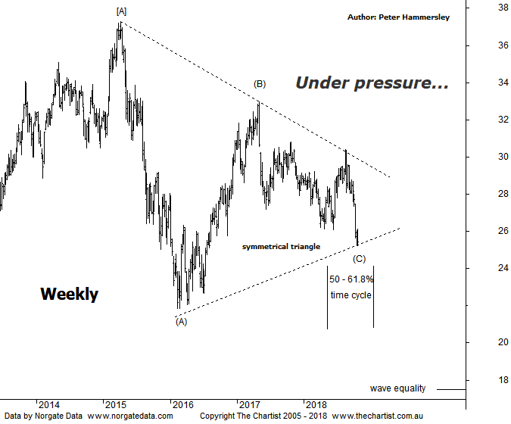

Bottom Line
24/10:
Daily Trend: Down
Weekly Trend: Down
Monthly Trend: Down
Support Levels: $21.86
Resistance Levels: $30.06 - $30.80 / $32.95
Video Analysis
Watch Video Analysis Here
Technical Discussion
ANZ is one of Australia's "Big 4" offering a range of banking and financial products to retail, corporate and institutional clients. Whilst ANZ is best known in Australia and New Zealand, it has a significant business in Asia. In July 2014, the company completed the sale of ANZ Trustees Ltd to Equity Trustees Ltd. For the six months ending the 31st of March 2018 interest income increased 3% to A$14.85B. Net interest income after loan loss provision increased 4% to A$6.94B. Net income before extraordinary items increased 34% to A$3.92B. Net interest income after loan loss provision highlights the increase in interest earning assets and decrease in interest bearing liabilities. Broker/Analyst consensus is currently “Hold”. The company pays a dividend of 6.3%.
Reasons to be cautious:
→ A slowdown in the banks owner-occupied home loan portfolio.
→ Affected by a high level of write-backs and recoveries in the institutional loan book.
→ Scope for additional buybacks in FY19/20.
→ A high degree of uncertainty due to the Royal commission.
→ Management delivering on cost reductions, credit quality and capital generation.
→ Higher bond yields will reduce pressure on net interest margins.
→ Improved credit quality and steady revenue trends.
→ Restructuring remains a focus.
→ The mortgage pricing war appears to have eased with discounting reduced.
The patterns in the big four banks have been changing recently and not for the better. All have exhibited large triangles although the lower trend lines on all except NAB have been breached. Last time were looking for weakness to take price down to the lower trend line to complete wave-(E) which would have set the stage for a leg higher. There’s no doubting the fact that weakness was the way forward although buyers didn’t appear in order to stop the rot. I have redrawn the lower boundary of the triangle here although we are pushing our luck to say the least. Considering the patterns in both CBA and Westpac advocate lower prices we must expect that ANZ here is going to follow suit. With this in mind I have put forward the wave equality projection sitting around $17.50 which is still a significant percentage decline from current levels. The problem with hitting that target area is that it will take price well beneath the 61.8% retracement level of the whole movement higher off the 2009 lows. The bottom line is, the patterns are now lacking clarity, with something likely needing to come out of left field to trigger an impulsive leg higher. That said, the company is looking oversold over the short-term meaning a bounce wouldn’t go amiss although there is no indication at this juncture that an interim low is locked in. Brokers have become a little more bullish on the banks due to the magnitude of the pull-backs though clearly there are headwinds. The dividends are becoming even more attractive which is now over 6% in this example. However, the question is whether the dividend is going to be sustainable moving forward. The market doesn’t appear to be convinced.
Trading Strategy
There was the potential for a buying opportunity around the lower boundary of the symmetrical triangle although having just amended the lower boundary of the pattern we must stand aside, especially as symmetry is now lacking. A lacklustre bounce would offer a shorting opportunity in the big four banks although that’s something to contemplate if and when a rally kicks in. Until then we are happily standing aside from the banking sector.

