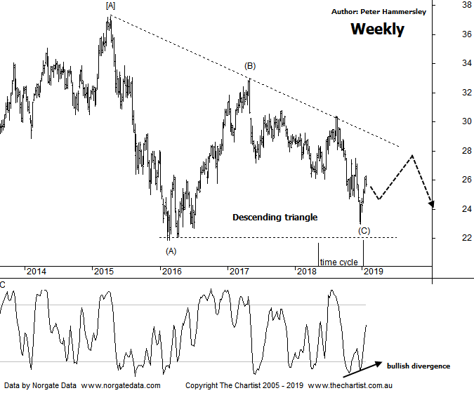

Bottom Line
23/1:
Daily Trend: Up
Weekly Trend: Up
Monthly Trend: Down
Support Levels: $21.86 / $17.43
Resistance Levels: $30.06 - $30.80 / $32.95
Video Analysis
Watch Video Analysis Here
Technical Discussion
ANZ is one of Australia's "Big 4" offering a range of banking and financial products to retail, corporate and institutional clients. Whilst ANZ is best known in Australia and New Zealand, it has a significant business in Asia. In July 2014, the company completed the sale of ANZ Trustees Ltd to Equity Trustees Ltd. For the six months ending the 31st of March 2018 interest income increased 3% to A$14.85B. Net interest income after loan loss provision increased 4% to A$6.94B. Net income before extraordinary items increased 34% to A$3.92B. Net interest income after loan loss provision highlights the increase in interest earning assets and decrease in interest bearing liabilities. Broker/Analyst consensus is currently “Buy”. The company pays a dividend of 6.1%.
Reasons to be cautious:
→ A slowdown in the banks owner-occupied home loan portfolio.
→ Affected by a high level of write-backs and recoveries in the institutional loan book.
→ Scope for additional buybacks in FY19/20.
→ A high degree of uncertainty due to the Royal commission.
→ Management delivering on cost reductions, credit quality and capital generation.
→ Higher bond yields will reduce pressure on net interest margins.
→ Improved credit quality and steady revenue trends.
→ Restructuring remains a focus.
→ The mortgage pricing war appears to have eased with discounting reduced.
Large consolidation patterns have been evident on all the big four banks over the past few months although they haven’t unfolded in textbook form. The problem with consolidation patterns is that quite often they morph into slightly different variants of the same pattern, which is the situation here. The symmetrical triangle we were looking at appears to have morphed into the descending variety, with wave-(C) completing a few weeks ago. There is no doubt that the banks have come into favour over more recent times, with impulsive price action higher unfolding, albeit only over the short-term. On this chart the door is now open to head up toward the upper boundary of the pattern which still offers plenty of upside potential over the coming weeks. However, clear rejection around the upper boundary would portend another decent leg South which could take price back down toward the lower trend line, which essentially is going to be acting as support during subsequent weakness. If we are to see an Elliott triangle, they should contain 5-internal swings which means there’s some posturing to be done before a more significant trend kicks into gear. Should the upper boundary of the triangle be overcome immediately then a more conventional triangle will be in place which would undoubtedly be a bullish proposition although there’s likely plenty of water to pass under the bridge before looking at upside targets. Bullish divergence is also providing a helping hand with price making a lower low whilst our oscillator has failed to confirm that weakness by making a higher low. It’s also triggered, with our indicator now well on its way into the overbought position although on this weekly chart it’s still going to take several weeks before unwinding fully. For now, we’ll go with the flow even though it’s far too early to be thinking in terms of a multi-year trend higher unfolding.
Trading Strategy
A quick look at the daily chart (not shown) shows a straight-line movement higher from the low made on Christmas Eve meaning at this juncture there’s no low-risk entry presenting itself. A micro consolidation pattern or even a short a-b-c would rectify this which is something we’ll be looking for over the coming days and weeks. As mentioned above, it’s difficult to get too enthusiastic longer-term at this juncture though there is scope for a quick swing trade should the smaller degree patterns permit. For now, it’s on the short term watchlist.

