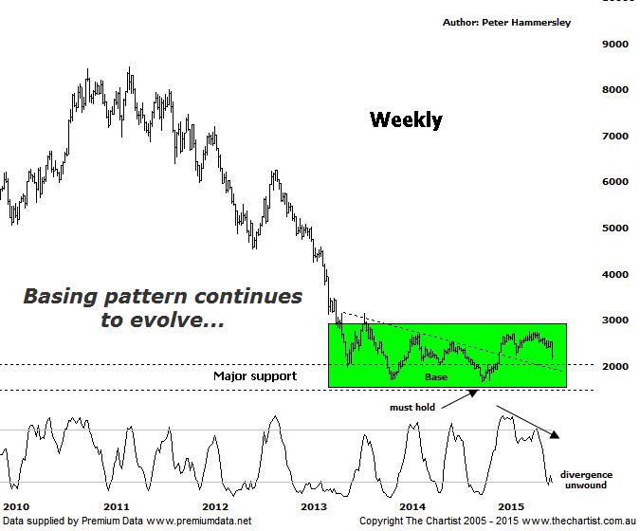

Bottom Line
22/7:
Daily Trend: Down
Weekly Trend: Down
Monthly Trend: Down
Support levels: 2069 / 1642
Resistance levels: 2760 / 3154
Video Analysis
Watch Video Analysis Here
Technical Discussion
Gold has been making the headlines for all the wrong reasons over the past few days as it has been coming under some serious pressure. It appears there are a number of reasons for its demise. First of all analysts and investors continue to look for a rate hike in the U.S. which will likely take place in September. Usually this will strengthen the U.S. dollar which in turn is a negative for the yellow metal – at least looking back at history this has been the case. It’s also been noted that the recent volatility on the back of the continued Greek saga has not triggered a move into gold which is exactly what many investors were expecting – purely on the back of its safe haven status. Finally, both China and India - which account for around 50% of demand for gold have been conspicuous by their absence in accumulating the metal during the recent retracement. In fact it’s been rumoured that China has been offloading although this cannot be substantiated and is purely speculation. The bottom line is that fundamentally all the news appears to be negative. So does this change our stance? Let’s take a look below.
Reasons to be ready for a buying opportunity:
→ Demand is rising with output declining.
→ A weaker U.S. dollar should boost the price of gold.
→ Continued concerns regarding global growth should also underpin prices.
→ Technically, buyers have stepped up around a major zone of support.
→ Sentiment is extremely low – often a contrarian bullish signal.
Interestingly enough the patterns for the gold sub sector shown here are looking healthier than those for gold itself. Gold has broken down through a significant make or break point at 11000 which automatically opens the door to continue down toward 10000. The positive here for the XGD though is that the basing pattern that we’ve been watching closely for several months now continues to evolve which in the bigger scheme of things keeps the door open for the next significant leg to be to the upside. In fact it would take a break beneath 1642 to move to a bearish stance and suggest that the longer term downtrend is going to reignite with a degree of attitude. This is something that needs to be avoided at all costs as it would put gold stocks on the back foot and would portend a significant decline from current levels. As it stands right here and now though the patterns continue to progress well despite the fact that our wanted breakout is taking longer to commence than would be deemed ideal. If we zoom into the more recent price action yesterday’s low only tagged the 50% retracement level of the prior leg higher which is perfectly normal at this stage of the trend. Price could even head down toward the 61.8% level at 2069 and still be deemed a healthy corrective pattern. For the moment that aforementioned make or break level is the line in the sand to keep close tabs on. On the positive side of things Type-A bullish divergence is in position on the daily time frame (not shown) although it has yet to trigger. If it does trigger over the coming days it could well be that a significant low is in position.
Trading Strategy
Our exposure to the gold sector has been limited to SBM over the past few months with the end result there being a nice profit. Our target was tagged and clearly rejected although that particular company is back on the watch list. For the moment we have to stand aside from the sector which is due to the increased volatility that has started to show. However, with almost everybody and their dog being extremely negative on the metal it could be worth considering the contrarian view. Generally speaking when sentiment is at extreme levels it’s time to sit up and take notice which is exactly what we’ll continue to do.

