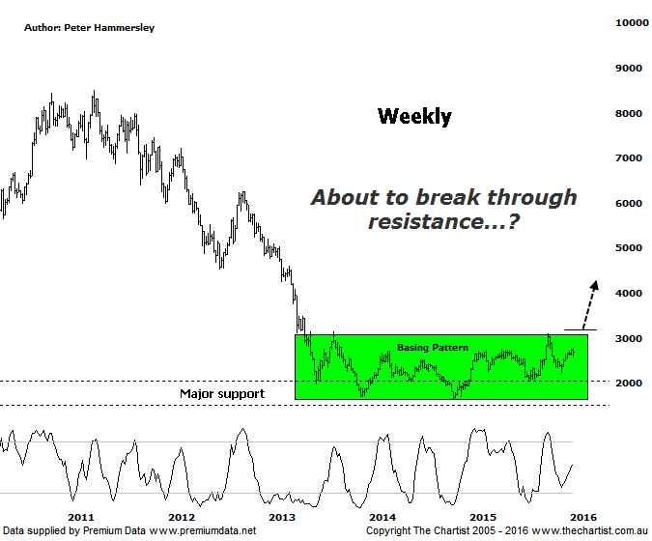

Bottom Line
14/1:
Daily Trend: Neutral
Weekly Trend: Neutral
Monthly Trend: Up
Support levels: 2226 / 2069 / 1642
Resistance levels: 3102 - 3154 / 4000
Video Analysis
Watch Video Analysis Here
Technical Discussion
It has been a poor few days for Gold although today did see the metal bounce which was likely the result of falls overnight in equity markets. As we all know, Gold is viewed as a safe haven when volatility in equities increases which is exactly what’s been unfolding recently. If this trait continues then the yellow metal could benefit and take price through some important technical levels which we’ll discuss below. Much is going to depend on the fed’s decision on interest rates and just how much they are going to rise. They have stated that they plan to hike rates four times this year although much is going to depend on data released over the coming months. Then there’s the U.S. dollar factor, with its recent show of resilience not the ideal situation for the gold price. All that said, there is one tailwind that needs to be taken into account; next month sees the start of the Lunar New Year which is seasonally strong for the metal. The Chinese culture means that Gold is often used as a gift at that time of year although to some extent one would expect this fact to be already factored in.
Reasons to be optimistic longer term:
→ Price has just broken out of a basing pattern.
→ Demand is rising with output declining.
→ A weaker U.S. dollar should boost the price of gold.
→ Continued concerns regarding global growth should also underpin prices.
→ Technically, buyers have stepped up around a major zone of support.
→ Sentiment has been extremely low – often a contrarian bullish signal.
There is nothing to be gained by moving to the daily time frame with the better patterns still viewed on the weekly chart. It’s difficult to get past the strong buying demand that’s been taking hold since 2013 which has resulted in the annotated basing pattern. This pattern is even more significant when taking into account the severity of the movement down into this region, plus we can’t forget that recent pivot lows have tagged and rejected from a major zone of support going back several years. To us this suggests that downside is limited and the next major move is likely to be higher. Just remember we are looking at the Gold Sub Sector chart here which shows different patterns to those on the gold chart itself. In fact, this is a much more bullish chart altogether which can only be viewed in a positive light. It’s also interesting that both rallies since August of last year (better viewed on the daily chart) have been impulsive in nature which is another step in the right direction. As long as any weakness is confined to corrective patterns there is still a good chance that price is going to break through the upper boundary of the trading range which should be extremely bullish. In summary, we can’t move to a firmer bullish stance quite yet but at least price is heading in the right direction and is now looking to take on the upper trend line of the basing pattern. All we need now is to see the breakout.
Trading Strategy
Our interest in the sector for the moment is confined to Newcrest Mining which is currently showing a decent gain with our initial target now achieved. We are continuing to hold using a trailing stop as there is still upside potential ahead. We are currently keeping a close eye on several gold companies in the ASX Chart Research Area which appear to be posturing for another leg higher. A little more patience is likely required though with bearish divergence still in position on the daily time frame of the XGD shown here. However, our oscillator is well on its way to the oversold position meaning it shouldn’t be a headwind for too much longer.

