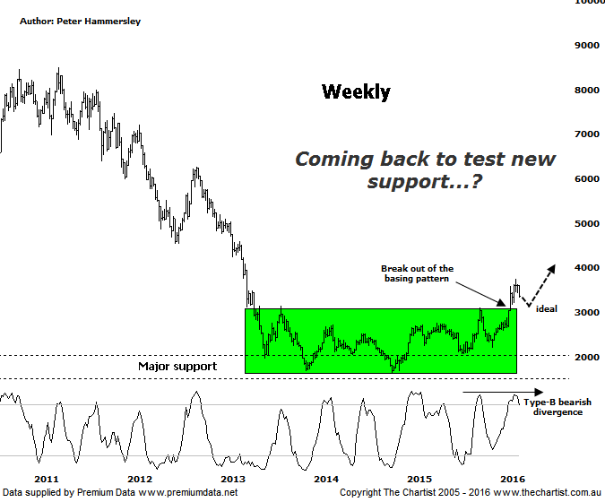

Bottom Line
16/3:
Daily Trend: Down
Weekly Trend: Up
Monthly Trend: Up
Support levels: 3182 - 3102 / 2226 / 2069
Resistance levels: 3746 / 4000 / 5070
Video Analysis
Watch Video Analysis Here
Technical Discussion
We noted last time around that there was still plenty of doom and gloom in the press regarding gold although the technicals suggested otherwise. We’ll come to those in a moment although it’s quite interesting that many analysts and even the press suddenly became extremely bullish on the metal following Draghi’s comments regarding stimulus measures and the central bank cutting its deposit rate. Bank stimulus is seen by most as a bullish proposition for the yellow metal as well. However, gold has actually been declining recently which just goes to show that fundamental analysis isn’t the be all and end all. At the end of the day we are far better concentrating on the price action and the patterns, letting those show us the way forward. One thing is for sure, the Gold sub sector shown here has rallied 68% from the early December lows which speaks for itself. A short retracement wouldn’t come as a big surprise although something more sinister isn’t anticipated.

Reasons to be optimistic:
→ Price has just broken out of a basing pattern.
→ Demand is rising with output declining.
→ A weaker U.S. dollar should boost the price of gold.
→ Continued concerns regarding global growth should also underpin prices.
→ Technically, buyers have stepped up around a major zone of support.
→ Sentiment has been extremely low – often a contrarian bullish signal.

Price is almost exactly where we left it during our last review although recovery highs have been made during the interim. The main pattern of interest is still better viewed on the weekly chart which is where we’ll keep our focus of attention this evening. Undoubtedly Price has broken higher in a strong impulsive movement which is another small step in the right direction. However, the upper boundary of the basing pattern is essentially old resistance and as we often state on these pages, price will often come back to retest the breakout area although it should now be acting as new support. This puts the recent weakness into perspective and from our point of view isn’t anything out of the ordinary. Interestingly enough, bearish divergence developed on the daily chart following our last look at the index which has no doubt been the reason for the recent retracement. Our oscillator has now made it back into the oversold position though meaning it’s no longer providing a headwind. The noted bearish divergence on the weekly chart is still apparent although it’s the less significant Type-B variant. That’s not to say it can be ignored although we aren’t expecting it to trigger a substantial leg South. The worst-case scenario at this stage is to come back to the area around 3000 although a push beneath that make or break point would be reason for concern, especially over the short to medium term. Conversely, a push above the recent pivot high at 3746 would mean that the prior uptrend is reigniting which ultimately is exactly what we are expecting.
Trading Strategy
In our recent reviews of NCM & EVN we noted the likelihood of seeing short-term weakness to complete small corrective pattern’s. This is still our expectation although we continue to be bullish the metal, and indeed the XGD meaning we are still on the lookout for buying opportunities. For the moment though, a little more patience is going to be required but if the patterns pan out as anticipated an opportunity shouldn’t be too far away. As always we’ll concentrate on the patterns pertaining to the individual stocks themselves though the chart here is a good guide in regard to what we can expect in the sector over the coming weeks and months.

