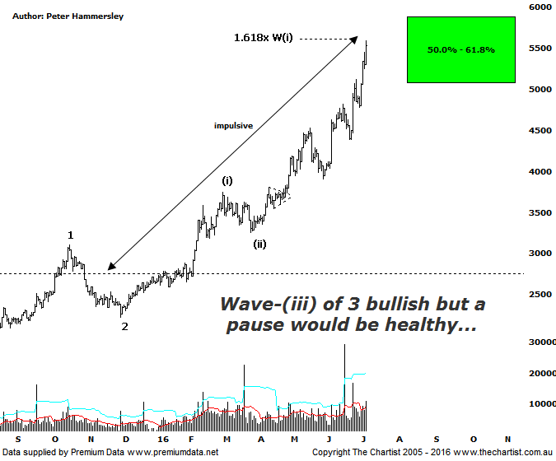

Bottom Line
6/7:
Daily Trend: Up
Weekly Trend: Up
Monthly Trend: Up
Support levels: 4697 / 4421
Resistance levels: 5879
Video Analysis
Watch Video Analysis Here
Technical Discussion
If you listen to the headlines in the press, then the reason for the recent surge in the price of gold has been Brexit. The yellow metal is reportedly benefiting from “safe haven” demand with investors flocking to it. There are arguments both for and against this theory but one thing to remember is that world equity markets have actually been rallying following the UK referendum result. As mentioned in Friday’s review of the XJO, the FTSE has been flying, hitting levels not seen since August of last year. Whether that strength is maintainable remains to be seen but it clearly shows that investors haven’t being selling stocks to move into gold and silver. In fact talking about the latter, there is talk of a short squeeze and the increasing use of the metal in solar panels as been the reason for the recent movement higher. So what conclusion can we draw from headlines in the press? They are best ignored as both bullish and bearish headlines are only printed to suit the price action. We prefer to concentrate on the technicals which is exactly what we’ll do now.

Reasons to be optimistic:
→ Price has just broken out of a basing pattern.
→ Demand is rising with output declining.
→ A weaker U.S. dollar should boost the price of gold.
→ Continued concerns regarding global growth should also underpin prices.
→ Technically, buyers have stepped up around a major zone of support.
→ Sentiment has been extremely low – often a contrarian bullish signal.

Before the recent break higher kicked into gear we were concentrating our efforts on the large basing pattern that took hold between mid-2013 and late 2015. This was always a bullish proposition and portended a decent leg higher once the breakout transpired. This just emphasises how potent these patterns can be with many companies within the Gold sector rallying just as hard. We are going to concentrate on the daily chart this evening though it is worth mentioning that the typical retracement zone of the whole leg down that commenced in April 2011 has now been tagged. So does this mean the bounce has run its course? It doesn’t, and for one very good reason. Since price broke up through resistance back in October of last year price action has been strong and impulsive in nature as opposed to being corrective. This always keeps the door open for something even more bullish to unfold which is still our expectation here. In fact, from an Elliott Wave point of view we have been labelling the chart as a potential 5-wave movement at larger degree. If our wave count is correct we are in wave-(iii) of the larger degree wave-3 which is about as bullish as it gets. This characteristic has been lacking in our market over the past few years due to the continued sideways chop. However, the XGD has certainly been showing traits of a wave-3 and has actually been exhibiting more bullish traits than even Gold itself. Zooming into the more recent price action shows that wave-(iii) should be underway with the 1.618 projection of wave-(i) coming within a whisker of being tagged today. This would be a logical place for this leg to draw to a conclusion meaning a pause for breath wouldn’t come as a great surprise around current levels. We also have to consider that parabolic price action isn’t particularly what we want to see as it usually means volatility is going to increase. A pause within the longer term uptrend here would also be deemed as being healthy. For now though, we’ll ride the trend higher until distribution starts to show.
Trading Strategy
We have been adding stocks within the gold sector to these pages over the past few months which really comes down to the strength that has been showing through. Out of seven open positions we currently hold two aligned to the Gold sector which provides us with good exposure. Having said that, we’ll continue to look for low risk entries and won’t hesitate in putting up more formal recommendations as they present themselves. Just remember though, it’s important to have diversification as you don’t want to put all your eggs in one basket. Over the longer term, that strategy will catch you out.

