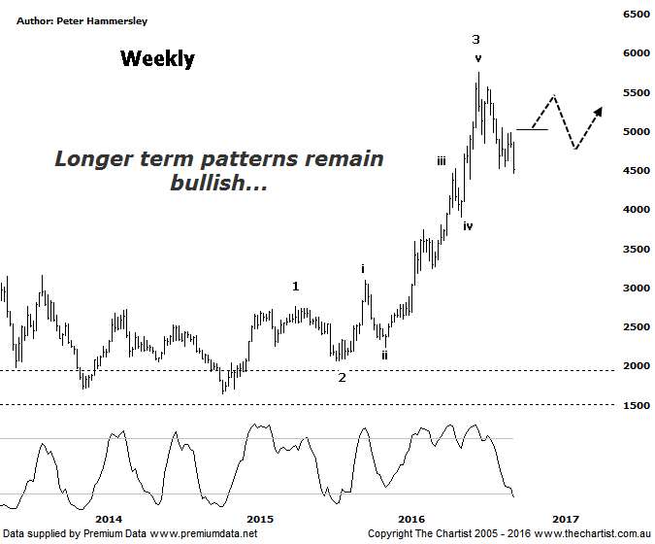

Bottom Line
5/10:
Daily Trend: Down
Weekly Trend: Down
Monthly Trend: Up
Support levels: 3905- 3746
Resistance levels: 5760 - 5879 / 6259
Video Analysis
Watch Video Analysis Here
Technical Discussion
Gold itself took a big hit last night as price probed down through the lower boundary of a trading range which is also a psychological level at $1300. In fact, it was the lowest level for the yellow metal since Brexit with a decline of well over 3% unfolding last night. This now opens the door for further consolidation or even another leg South before the strong prior uptrend reignites further down the track. One of the perceived problems according to analysts is the US dollar which has been looking stronger recently. Although it’s old news there’s also the expectation that US interest rates could rise sooner than anticipated which all things being equal should be negative for gold itself. Global equity markets in general have also been looking stronger meaning the “safe haven” attraction is no longer supporting prices. There is also talk about both gold and silver suffering from diminishing physical demand with Thomson Reuters pointing out that physical sales in the US recently fell by more than 40% in the third quarter. All this being said, nothing changes from our perspective with plenty of upside potential ahead over the longer term, albeit there is now downside risk over the coming weeks.

Reasons to be optimistic (caution short-term):
→ Price action is impulsive out of the basing pattern.
→ A weaker U.S. dollar should boost the price of gold.
→ Continued concerns regarding global growth should also underpin prices.
→ Sentiment has deteriorated further – often a contrarian bullish signal.
“…Taking a look at several of the stocks we cover in the sector shows there is potential to see short-term weakness or even a sideways consolidation with a bias to the downside…” These were our comments in the review of RSG last night although we certainly weren’t expecting the severity of the movement down last night. Still, in regard to the patterns in most of the stocks we cover in the gold sector, there is a need for further weakness to complete larger corrective patterns. However, as significant as last night’s decline was, there’s no reason to panic. We are going to move back to the weekly chart this evening to take stock of the larger degree patterns which show the potency of the movement higher out of the long-term zone of support which is where the basing pattern formed. Our wave count shows that the recent pivot high completes larger degree wave-3 which fits in nicely with the retracement over the past few weeks which for the most part has been choppy and messy in nature despite last night’s sell-off. If our wave count is correct we’d expect to see a broader consolidation phase as opposed to an impulsive leg lower meaning another couple of days like today would be reason for concern, thus giving us reason to reassess the patterns. However, we can’t read too much into one day’s price action so we’ll let the smaller degree patterns show us the way forward from here although at the moment any bounce is likely going to be choppy and messy and therefore corrective in nature.
Trading Strategy
We took a small loss on AQG a couple of days ago with our initial stop being tagged although this just reiterates how important trade management is. Once the patterns fail there is simply no reason to be holding and hoping as this usually results in a much larger loss which of course is much more difficult to recover from. The only other stock we are holding in the sector is SBM although we have a tight protective stop in position which will defend us should Gold continue to take a turn for the worse. As stated above, there is room for many of the stocks we cover in the sector to continue to head south although we are still of the opinion that ongoing weakness over the coming weeks could present an exceptionally good buying opportunity. For now though caution is required.

