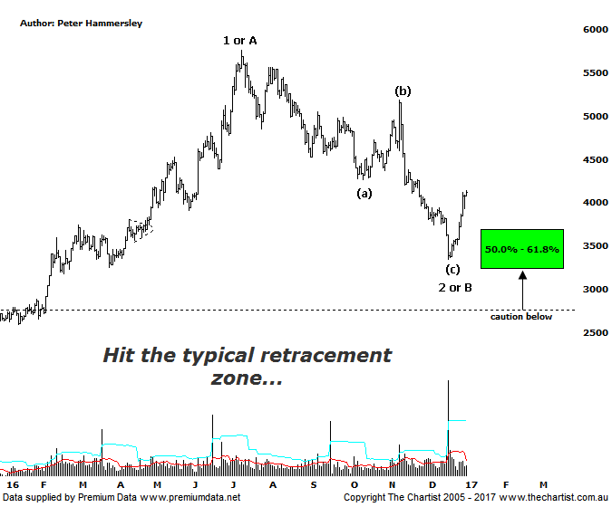

Bottom Line
4/1:
Daily Trend: Up
Weekly Trend: Down
Monthly Trend: Down
Support levels: 3215 / 3102 - 2760
Resistance levels: 5760 - 5879 / 6259
Video Analysis
Watch Video Analysis Here
Technical Discussion
The bid has come back into gold over the past couple of weeks resulting in a gain of around 15% for the XGD. However, the decline since July of this year has been substantial, resulting in a loss of around 42% to the recent low. One of the problems for the yellow metal is a strong US dollar which continues to be buoyant. This usually has a negative effect on assets priced in the currency. Although it’s not always the case, gold also usually moves inverse to the US stock market which of course continues to look strong. The two can move in unison when uncertainty is centre stage although what the trigger will be is anyone’s guess. It could be the nuclear threat from North Korea or even Trumps attitude with China, though this is purely speculation at this juncture. The other influencing factor for gold is the expectation that the US is going to stimulate economic growth which in the past has been detrimental for gold prices. The bottom line is that there are many factors influencing the yellow metal which need to be watched carefully for clues.
Reasons to remain optimistic (caution short-term):
→ A lot of bad news has already been factored into prices.
→ Price action is impulsive out of the basing pattern.
→ A weaker U.S. dollar should boost the price of gold.
→ Concerns regarding Trump’s long-term effects on the US economy could bolster the yellow metal.
→ Sentiment has deteriorated further – often a contrarian bullish signal.
Whilst most pundits are suggesting gold is doomed, the chart of the Gold Sub Sector hasn’t been aligning with this expectation. There is no doubt that the patterns have deteriorated since our last review although we certainly haven’t moved to a bearish stance longer term. However, we were looking for the recent retracement to complete wave-4 on the weekly chart although the depth of the retracement has been too severe. As such, it now seems likely that the deeper correction completes wave-2 or-B although this still has bullish implications short to medium term. The prerequisite is that recent strength continues with anything other being reason for concern. This evening we are going to move to the daily timeframe which shows that the recent leg South terminated in the typical retracement zone of the whole prior leg higher out of the basing pattern. Talking of which, the basing pattern is still a very bullish aspect of this chart and as long as price doesn’t move back into that trading range then the risk remains to the upside. The line in the sand right here and now sits at 3215, being the 61.8% retracement level. Should this be exceeded we move back to a neutral stance although this wouldn’t be deal from an Elliott perspective. The recent bounce has been helped by Type-A bullish divergence although our oscillator has now headed into the overbought position. On the weekly chart though our oscillator still has room to head significantly higher having just broken out of oversold territory.
Trading Strategy
We continue to remain on the sidelines regarding exposure to gold although our interest has been rekindled. That said, further confirmation regarding a low being in position is required in most of the stocks we cover before taking the plunge. A higher swing low pattern or similar would be a step in the right direction which means a little more patience is going to be required. Keep an eye on the Position Status Page over the coming weeks though as we may well put forward recommendations without doing a formal review if low risk entries present themselves.

