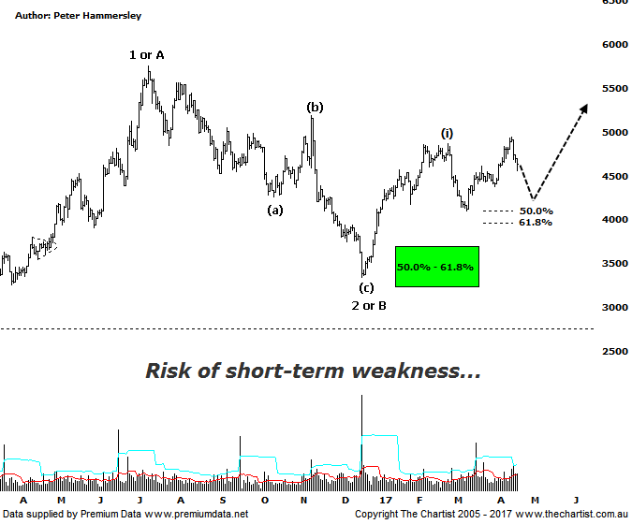

Bottom Line
20/4:
Daily Trend: Down
Weekly Trend: Up
Monthly Trend: Up
Support levels: 4104 - 3925 / 3345
Resistance levels: 4948 - 5189 / 5760 - 5879 / 6259
Video Analysis
Watch Video Analysis Here
Technical Discussion
There’s no doubting the fact that the bid has come back into Gold though the question remains as to whether recent strength is going to be sustainable. A weakening US dollar has provided a tailwind for the yellow metal although geopolitical risks have probably had more of an influence. The missile strike on Syria is getting to be old news although there is still uncertainty regarding North Korea and their intentions regarding testing. Although many experts state that gold isn’t a safe-haven, the fact remains that investors flock to it in their droves when all is not well in the world. There’s also Trump’s economic policies to consider. In fact, it’s not so much the policies but more so the probability of them coming to fruition, as roadblocks are starting to appear. One of the main negatives is interest rates in the US which all things being equal should be bearish for the metal. However, as it’s now a given that rate hikes are going to continue, this is almost certainly already factored into prices. All things being equal the risk seems to be to the upside, at least over the short-term.
Reasons to remain optimistic (caution short-term):
→ Recent geopolitical issues have provided a tailwind.
→ Impulsive price action higher has commenced.
→ A lot of bad news has already been factored into prices.
→ Price action is impulsive out of the basing pattern.
→ A weaker U.S. dollar should boost the price of gold.
→ Concerns regarding Trump’s long-term effects on the US economy could bolster the yellow metal.
We’ve been concentrating on the smaller degree patterns via the daily timeframe which have been progressing very well from a bulls perspective. During our last review we were looking for a probe down into the typical retracement zone toward 4000 which is now a box that can be ticked. Indeed, the 50% retracement level was tagged to the point before buyers stepped in, driving price higher. The only problem is that the retracement was a straight-line movement which is not indicative of completing the countertrend move. As such, the door is open to see short-term weakness, eventually taking price down toward the recent pivot low circa 4162 to complete a flat pattern. This would be ideal as it would show much more symmetry both in terms of the patterns and time. It’s also interesting that the movement up to the recent pivot high is now confirmed as being a corrective pattern as overlap has occurred; I’ll take a closer look at this during this evening’s video. On the weekly chart (not shown) bearish divergence is in place and has even triggered which increases its significance. This is one of the most reliable tools in the box and is something we can never ignore, especially when it’s the Type-A variant which is the situation here. As it’s present on the larger timeframe it should take several weeks for our indicator to unwind into the oversold position meaning caution is required. During our next review we’ll be focusing on the larger degree patterns as there’s a chance that the recent pivot low made in December last year is only the initial stage of a larger corrective pattern. This is based on the retracement not taking the minimum 38.2% of the time taken by the prior trend. For now though, we’ll keep abreast of the smaller degree structures and see whether our wanted brief probe lower kicks in.
Trading Strategy
We don’t currently have any exposure to Gold as many of the stocks we cover appear to be in the midst of larger corrective patterns, albeit downside appears limited. Yes, we’ve missed the latest leg higher although as mentioned above, recent strength has almost certainly been triggered by news events which is always reason for scepticism. When the dust settles, and ideally the current corrective patterns complete we’ll be looking to put forward recommendations. Until that time further patience is required.

