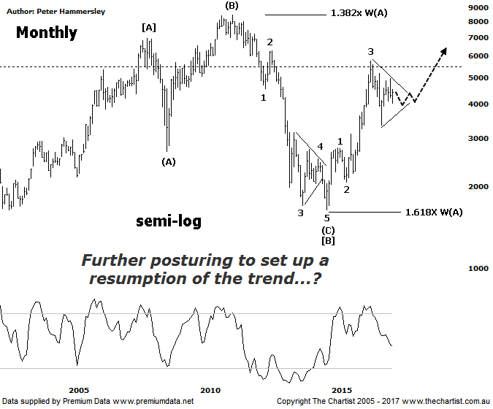

Bottom Line
18/5:
Daily Trend: Up
Weekly Trend: Down
Monthly Trend: Down
Support levels: 4027 - 3925 / 3345
Resistance levels: 4948 - 5189 / 5546 / 5760 - 5879
Video Analysis
Watch Video Analysis Here
Technical Discussion
Gold has been given a boost over the past few days on the back of global tensions with North Korea and political concerns in the US. A possible escalation with North Korea has had a few investors looking for the safe-haven trade, and the yellow metal fits the bill for many people. Longer term, calling gold a safe-haven is a fallacy although we won’t get into that argument here. Suffice to say, when uncertainty reigns, gold usually benefits over the short-term. Donald Trump is never far from the news and once again he’s hit the headlines in the New York Times. They report that he has tried to influence an FBI probe into links with Russia. Whether this is true is anyone’s guess although again, the news has been influencing markets overnight. There are even comparisons with the Watergate scandal although of course this is only headline grabbing news and may prove to be totally insignificant. We firmly believe that these news events only have a minimal impact on prices with new news soon becoming old news. Many analysts are citing the imminent US Fed rate hike in June as being a bearish catalyst although this is highly likely already factored into prices. Silver has also recently taken a knock from a sell-off in base metals and bulks amid Chinese concerns. For now though, headline news is driving gold higher which means we must be on alert for increased volatility.
Reasons to remain optimistic (caution short-term):
→ Recent geopolitical issues have provided a tailwind.
→ Impulsive price action higher has commenced.
→ A lot of bad news has already been factored into prices.
→ Price action is impulsive out of the basing pattern.
→ A weaker U.S. dollar should boost the price of gold.
→ Concerns regarding Trump’s long-term effects on the US economy could bolster the yellow metal.
We are going to run with a more bullish count on the Gold sub sector (XGD) even though bigger picture it appears that a large corrective pattern is taking price higher. We shouldn’t be put off by the corrective nature of the price action longer term, as there is still exceptional upside potential ahead, albeit a little more time may be required before the next impulsive movement higher kicks in. We have labelled the high made in January 2008 as wave-[A] from where a correction has taken place. Although the high of wave-[A] has been overcome it appears that an expanded flat completes wave-[B]. This is undoubtedly a bullish interpretation of the patterns although the subsequent strong impulsive leg higher adds weight to our labelling. With these types of flat corrections, wave-(B) often hits the 1.382 projection of wave-(A) which as can be seen was tagged almost to the point. Also, wave-(C) usually travels 1.618x the length of wave-(A) which is another box that can be ticked. At lower degree, the recent pivot high completes wave-3 from where a consolidation phase appears to be unfolding which is typical at this stage of the trend. Ideally, we’d like to see a symmetrical triangle or flat pattern unfold over the coming months which means consolidation is likely going to be the way forward, albeit remember we are looking at the monthly timeframe here so there will be decent trends along the way on the smaller timeframe. A push above the upper trend line of the proposed triangle would offer a continuation up toward the wave equality projection taken off the daily chart sitting up around 5546 as an absolute minimum. To invalidate our longer-term wave count price would need to head beneath the high of wave-1 at 2760 which isn’t looking likely at this stage. The prior trend is strong which means we need to be aligned to the bulls over the coming years.
Trading Strategy
Many of the Australian gold stocks have made reasonable retracements over the past few months despite the bounce that’s been unfolding over the past few days. We don’t currently have any exposure to the sector although some companies are starting to look very interesting. SBM is one that immediately comes to mind with price recently breaking up through a solid zone of resistance although today did see some rejection which needs to be watched carefully. Consolidation in this region for a few days would be ideal and keep the short-term bullish case alive. We’ll be looking at the smaller degree patterns on St Barbara next week as a very good buying opportunity could only be a few days away.

