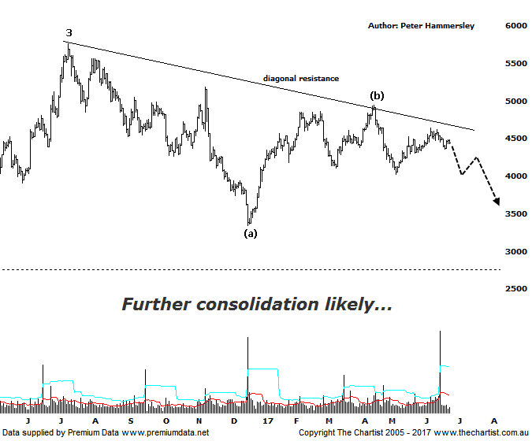

Bottom Line
26/6:
Daily Trend: Down
Weekly Trend: Neutral
Monthly Trend: Up
Support levels: 4027 - 3925 / 3345
Resistance levels: 4948 - 5189 / 5546 / 5760 - 5879
Video Analysis
Watch Video Analysis Here
Technical Discussion
Weakness in assets perceived as being risky, plus declines in the US dollar has given gold itself a boost over the past few sessions although that’s as good as the news has been for the metal over recent weeks. Volatility in equity markets remains exceptionally low which is one of the reasons for the stagnation in price of the yellow metal since February of this year. Last week the Federal reserve increased interest rates which is usually seen as bearish signal for gold. However, this has been well signalled over recent months and is likely already factored into prices. Interestingly, the St. Louis Fed President recently stated that the FED could feasibly refrain from raising short-term interest rates to see how the economy progresses. The bid could also return to precious metals as concerns regarding the impact of falling oil prices hits home. In terms of time, it’s worth noting that demand in both China and India has been increasing recently which is common at this time of year. These could all be supportive of prices, albeit they are unlikely to be bullish triggers right here and now. Bigger picture, we’ll continue to run with the patterns which suggest a sideways meander for the foreseeable future before heading higher again in a strong move.
Reasons to remain optimistic (caution short-term):
→ History shows that gold rallies during cycles of rate-hikes.
→ Recent geopolitical issues have provided a tailwind.
→ A lot of bad news has already been factored into prices.
→ Price action is impulsive out of the basing pattern.
→ A weaker U.S. dollar should boost the price of gold.
→ Concerns regarding Trump’s long-term effects on the US economy could bolster the yellow metal.
One interesting fact regarding gold which seems overlooked is that it usually rises during cycles of increasing rates. In fact, it’s recently been reported that the yellow metal has rallied in all but one of the past seven rate-hike cycles since the 1970s. This of course is the opposite of what most analysts, as well as the press suggest with rising interest rates perceived as being bearish. Although everything has gone quiet regarding the Trump administration, there’s always a possibility that something is going to come out of left field which keeps the door open for investors to scramble to safe haven assets although of course this is purely speculation. During our last look at the XGD, we concentrated on the monthly chart which showed that a larger degree wave-4 was likely unfolding meaning several months of consolidation in this region was anticipated. Nothing changes in that regard meaning some patience is likely going to be required before a resumption of the trend that commenced in 2014 reignites. We have tentatively pencilled in the upper boundary of a symmetrical triangle although if this is the case it’s still only in its early stages. With wave-(b) recently locked in. It would take a push above 5000 to suggest something more bullish is going to unfold earlier than anticipated although a continuation above the high of wave-3 circa 5760 before becoming bullish immediately. Not impossible, but there’s going to need to be a catalyst before getting up through those levels any time soon. On the weekly chart (not shown) Type-A bearish divergence is also an issue and could be a headwind for the foreseeable future.
Trading Strategy
If we are correct regarding the patterns we don’t want too much exposure to the gold sector although as always, we’ll run with the patterns pertaining to the individual stocks themselves as opposed to concentrating too much on this particular chart. We currently only have exposure through EVN and the way the patterns are looking in most of the stocks we cover, it could be a while before another setup is put forward. Either way, longer-term we continue to like what we see but now isn’t the time to be over exposed to the sector.

