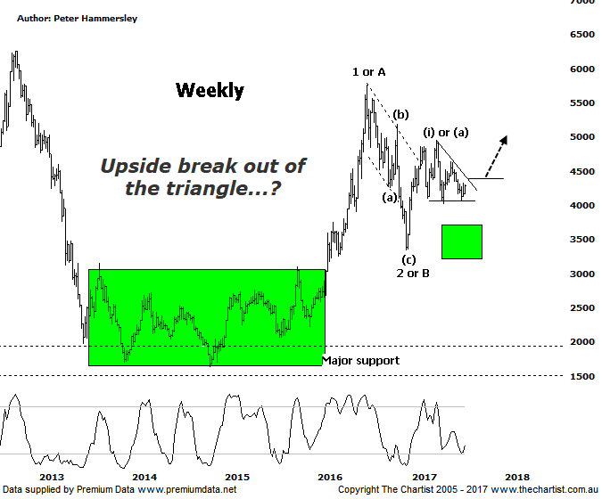

Bottom Line
3/8:
Daily Trend: Up
Weekly Trend: Down
Monthly Trend: Down
Support levels: 4027 - 3925 / 3345
Resistance levels: 4948 - 5189 / 5546 / 5760 - 5879
Video Analysis
Watch Video Analysis Here
Technical Discussion
Regarding seasonality, the run-up to July tends to be weak which is exactly what’s unfolded this year. However, the most bullish month is September and with the run-up in the yellow metal over the past few weeks it could well be that strength is going to be the main theme, at least over the short-term. Funnily enough, September also tends to be the worst for US indices although this shouldn’t really come as a great surprise. Fundamentally, there are reasons to be bullish gold. It’s Reported that over 50% of gold jewellery demand arises from weddings, with India being especially keen. With the growing middle-classes around the world this trait will likely continue or even strengthen. Gold bulls will also remind us of the safe-haven benefits, especially with governments around the globe continuing to print money. This is undoubtedly true although it’s a well-known fact and therefore should already be priced in. That said, we continue to be bullish on gold itself medium to longer term although it’s undoubtedly range-bound currently.
→ Reasons to remain optimistic (caution short-term):
→ History shows that gold rallies during cycles of rate-hikes.
→ Recent geopolitical issues have provided a tailwind.
→ A lot of bad news has already been factored into prices.
→ Price action is impulsive out of the basing pattern.
→ A weaker U.S. dollar should boost the price of gold.
→ Concerns regarding Trump’s long-term effects on the US economy could bolster the yellow metal.
This evening we are going to flip back to the weekly chart which shows the triangle scenario we put forward last time a little more succinctly. First of all we’ll go all the way back to 2013 which is where buyers started to step up to the plate. The end result was a large basing pattern that lasted around 2 ½ years before price finally broke higher in impulsive fashion. This is a large step in the right direction as it opens the door for substantially higher levels, albeit the smaller degree patterns advocate caution. Not that we are looking for a significant retracement but it could well be that price needs to consolidate in this general area for several months before an attempted break higher commences. We have left the bullish interpretation of the wave count on the chart which shows the late 2016 lows as completing wave-2 or-B. The recent pivot high completes intermediate degree wave-(i) or-(a) with the triangle as annotated looking to draw to a conclusion at any time. Should this wave count be correct then impulsive price action higher needs to kick in pretty much immediately although remember we are looking at the weekly chart here. How strength unfolds will provide the big clue as to whether the XGD is ready to trend right here and now or needs further time to consolidate. Unless price starts to gain some traction over the next month or so there is a strong chance that a much larger consolidation pattern from the high of wave-1 or-A is materialising. This could take a couple of years to conclude. Not ideal as it will make for frustrating trading conditions though it’s a possibility that can’t be ignored. For now we’ll concentrate on what reaction is seen once the triangle breaks.
Trading Strategy
We currently only have exposure to gold via RRL which sits around breakeven. Many companies we follow are in a similar position to the chart shown here in that price has been consolidating for a considerable period of time. If the upper boundary of the triangle here is penetrated more opportunities may come our way. We are keeping close tabs on the likes of SBM & EVN although more patience is likely required before setups are presented.

