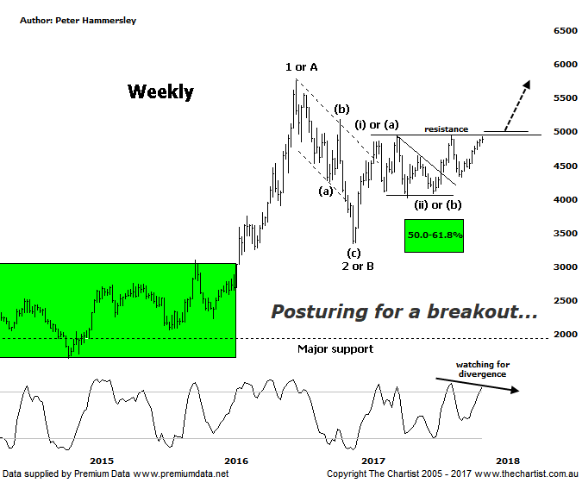

Bottom Line
29/11:
Daily Trend: Up
Weekly Trend: Up
Monthly Trend: Up
Support levels: 4027 - 3925 / 3345
Resistance levels: 4948 - 5189 / 5546 / 5760 - 5879
Video Analysis
Watch Video Analysis Here
Technical Discussion
Many of us will have woken this morning to news that North Korea had just fired another missile. Many will also have taken a quick look at the price of gold to see whether it had spiked on the news although nothing could be further from the truth. It appears that the market is now shrugging its shoulders regarding the antics of Kim Jong-un, probably because it’s happened so many times before. It’s also interesting that US indices had one of their best sessions for several weeks last night with the missile news also being largely ignored by investors. That’s not to say escalation further down the track won’t have a different effect although for the moment it’s hardly even making headline news. Markets are focusing more on US interest rate policy as this is going to have more of an effect over the medium to longer term. Data last night showed a monthly jump in US consumer confidence which is at its highest level in 17 years. This arguably adds weight to the argument by the Fed that further rate increases are likely. Talking of the Fed, Yellen is due to leave the chair in February with the Senate Banking Committee yesterday confirming that Powell is in line to become the Fed chairman. Powell has been quoted as saying he will continue with the plan laid out by Yellen which includes raising interest rates and allowing a gradual shrinking of the balance sheet.
Reasons to remain optimistic:
→ History shows that gold rallies during cycles of rate-hikes.
→ Recent geopolitical issues have provided a tailwind.
→ A lot of bad news has already been factored into prices.
→ Price action is impulsive out of the basing pattern.
→ A weaker U.S. dollar should boost the price of gold.
→ Concerns regarding Trump’s long-term effects on the US economy could bolster the yellow metal.
We haven’t looked at the Gold sub sector for several weeks now which is down to the fact we’ve been concentrating on the weekly chart. Last time, we were focusing on the upside break out of the descending triangle and the subsequent weakness. The bottom line was that buyers needed to step up pretty much immediately which is exactly what they’ve done. The prior pivot high and the line of resistance just beneath 5000 is now coming under attack with the ideal situation being to see an upside break and strength that sticks. This would be a big confidence booster regarding our wave count whilst also opening the door for a substantial rally to unfold. What the bullish trigger will be for such a move is anyone’s guess although as mentioned above, the antics of North Korea are now having no effect whatsoever. The larger degree patterns continue to look exceptionally bullish with a strong impulsive movement higher out of the multi-year basing pattern culminating in wave-1 or-A from where a textbook corrective pattern took price into the typical retracement zone. Even at smaller degree the patterns continue to unfold very nicely although it’s now important that the next move is up otherwise clarity starts to wane. One thing we need to be aware of is bearish divergence. There is a very weak example of Type-A divergence on the daily chart (not shown) and although it’s not in place on this weekly chart yet, it’s something to look out for over the coming days and weeks. One thing we can’t afford to see is a fakeout which essentially means a false break up through the line of resistance. The divergence isn’t major reason for concern at this stage but if it triggers on the weekly timeframe it isn’t going to unwind overnight, it’s going to take several weeks as a minimum.
Trading Strategy
One big positive is that price is posturing in exactly the right place, with a push above 4948 in a move that sticks adding weight to the more bullish case. Just be aware of the bearish divergence mentioned above though as this will be significant and a headwind for several weeks should it trigger. If the breakout transpires we’ll be looking to put forward recommendations within some of the stocks we cover that are aligned to the yellow metal, of which there are several. We’ll be watching the price action here closely over the coming days as there is plenty of upside potential if the smaller degree patterns play out as anticipated.

