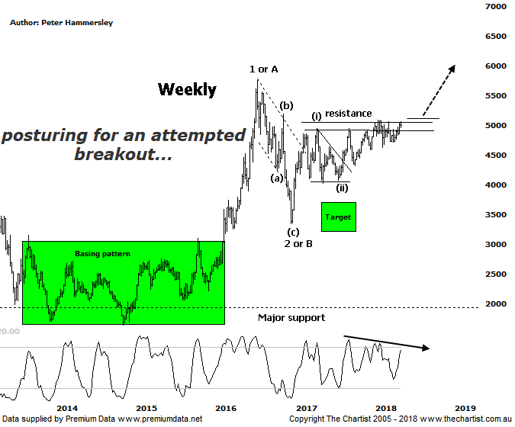

Bottom Line
2/5:
Daily Trend: Up
Weekly Trend: Up
Monthly Trend: Up
Support levels: 4630 - 4587 / 4027 - 3925 / 3345
Resistance levels: 5087 - 5189 / 5760 - 5879
Video Analysis
Watch Video Analysis Here
Technical Discussion
Gold itself has been on the back foot recently and last night hit levels not seen for a couple of months. As long as price can stay above $1300 an ounce there isn’t major reason for concern although there isn’t too much room for further weakness if that psychological level is to remain intact. A strong US dollar and Treasury yields climbing combined with the much awaited Federal reserve’s monetary policy decision (which will be released on Wednesday) are undoubtedly having an impact on the yellow metal. Most analysts are of the opinion that the Central bank will not alter its policy which if correct could restore some confidence and set the stage for a rally in gold. Generally, higher treasury yields equal weakness for gold which of course doesn’t provide a yield. This is the point the bears are making although of course it isn’t quite that clear-cut. Other data also has an influence, with yesterday’s PCE index data suggesting there will be more hikes by the Fed. The ISM prices index is also at its highest level since 2011 which brings back the question of rising inflation. The bottom line is, from a fundamental perspective there are many arguments for both higher and lower prices for the metal which is why we concentrate on the patterns which will ideally continue to show us the way forward.
Reasons to remain bullish longer term:
→ History shows that gold rallies during cycles of rate-hikes.
→ Recent geopolitical issues have provided a tailwind.
→ A lot of bad news has already been factored into prices.
→ Price action is impulsive out of the basing pattern.
→ A weaker U.S. dollar should boost the price of gold.
→ Concerns regarding Trump’s long-term effects on the US economy could bolster the yellow metal.
Price had just rejected from the line of resistance during our last review meaning more time was likely going to be required before our wanted breakout kicked into gear. However, despite gold itself struggling for traction, the Gold sub sector (XGD) has been holding firm with many of the companies we cover in the sector showing good resilience. Bearish divergence was also a problem last time although it hasn’t proven to be overly significant which in this instance can be viewed in a positive light. Again, we’ll concentrate on the weekly chart today which shows the much clearer patterns. It also shows that the upper boundary of the zone of resistance is being challenged meaning at least we are posturing in the right area. However, we’ve seen five or six attempts at breaking up through current levels and until we see a breakout that sticks we must remain cautious. A quick look at the daily chart shows that bearish divergence is in place although it’s not a textbook example. However, if it triggers it could be that price needs to consolidate further until our indicator rotates down into the oversold position - or invalidates. As far as the wave count is concerned nothing changes although if we are to see a true wave-(iii) it’s essential that a break higher commences sooner rather than later as price action has become choppy recently. In fact, price is still around the same levels as it was back in September 2016 which has made for some frustrating trades. We are as confident as we can be that the next move is going to be to the upside meaning we need to remain patient and let the patterns either validate or invalidate our analysis.
Trading Strategy
We continue to hold both PRU & AQG meaning we have plenty of exposure to the sector. Price hasn’t taken off yet in either stock although at least it is heading in the right direction which is all we can really ask for considering how gold has been travelling recently. Just remember, although we probably won’t put forward another recommendation in the sector for a while there will be setups put forward within the reviews themselves if you don’t yet have exposure or want to increase it. As mentioned above, price is sitting in exactly the right place on this chart although the breakout will be the icing on the cake.

