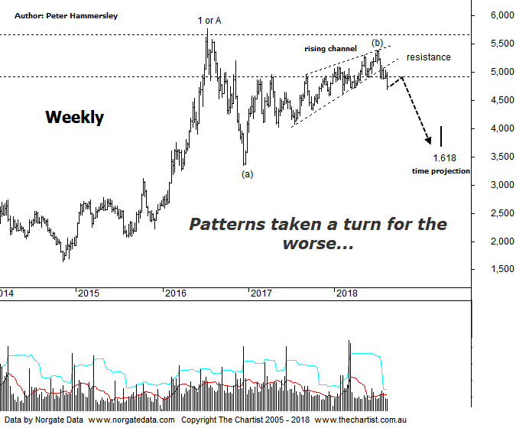

Bottom Line
16/8:
Daily Trend: Down
Weekly Trend: Down
Monthly Trend: Down
Support levels: 4027 / 3345
Resistance levels: 5760 - 5879
Video Analysis
Watch Video Analysis Here
Technical Discussion
We’ve noted several times over the past few months that the resilience of our gold miners has been a result of currency tailwinds, plus some bullish quarterly reports from the likes of SBM, EVN & PRU which have undoubtedly provided a helping hand. However, tailwinds don’t last for ever and our miners have now come under pressure. Last night gold itself closed at around an 18-month low as metals continued to sell-off. The U.S dollar has now hit around a 15-month high which hasn’t been helping. Concerns regarding Turkey haven’t proven to be a stimulus for gold due to its “safe-haven” appeal, with the US dollar benefiting instead. Looking back at the charts shows that gold doesn’t tend to do well during times of risk aversion, despite what many commentators suggest. It doesn’t seem long ago that we were talking about the psychological $1300 level although now analysts are concentrating on $1200 as being a new area of resistance. This is all very interesting but what are the patterns telling us?
Reasons to remain bullish longer term (caution short to medium-term):
→ History shows that gold rallies during cycles of rate-hikes.
→ Recent geopolitical issues have provided a tailwind.
→ A lot of bad news has already been factored into prices.
→ Price action is impulsive out of the basing pattern.
→ A weaker U.S. dollar should boost the price of gold.
→ Concerns regarding Trump’s long-term effects on the US economy could bolster the yellow metal.
“…If I am to be picky it could be argued that the leg higher off the December 2016 lows hasn’t been particularly strong and impulsive in nature although higher highs and higher lows continue to form meaning we simply go with the flow…” Hindsight is a wonderful thing although our concerns regarding the choppy price action higher has proven to be significant. The big positive last time was the push up through a solid area of resistance which was then acting as support. The bad news is that the strong leg down over the past few days has meant that the zone of support has failed which again flips it back to acting as resistance. I have amended the upper boundary of the zone of resistance although in reality nothing changes with clear rejection being witnessed over the past few weeks. The lower boundary of a rising wedge has also been penetrated which opens the door to head down to the origin of the pattern which sits around 4079 and is a high probability target area. This coincides quite nicely with the 50% - 61.8% retracement zone of the whole leg higher that commenced in December 2016 providing some confluence. From a pure Elliott Wave perspective there is scope to head down to the low of wave-(a) as annotated to complete a long elongated corrective pattern from the high of wave-1 or-A. I’ve also put forward the 1.618 time projection of wave-1 or-A which takes us into April of next year. A rotation down toward those lower levels on that timeframe would be deemed the worst-case scenario although it’s not out of the question. At the end of the day, the patterns have deteriorated meaning caution is required.
Trading Strategy
As we mentioned in last night’s review of GOR, we don’t currently have any exposure to the gold sector although we do have a trade waiting to trigger in NCM. However, with gold looking the way it is, it could be that the setup is going to be invalidated over the next week or two. Not that we refrain from making trades in a particular stock just because sectors are looking weak, as patterns do change. That said, the companies we cover in the sector appear to be embarking on larger corrective patterns meaning the sidelines isn’t a bad place to be.

