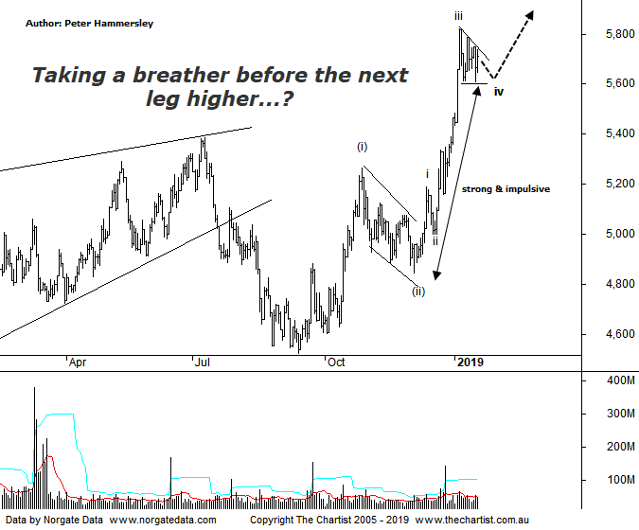

Bottom Line
17/1:
Daily Trend: Up
Weekly Trend: Up
Monthly Trend: Up
Support levels: 5386 - 5264 / 4910 - 4881 / 4027
Resistance levels: 5760 - 5821 / 6259
Video Analysis
Watch Video Analysis Here
Technical Discussion
Technically the gold sub sector was at a very important juncture during our last review having hit a potential reversal zone. We were looking for higher prices and we haven’t been disappointed although more on the technical aspects below. The yellow metal has been performing well recently and continues to hover around $1300 an ounce which is a psychological area of importance. A push up through that aforementioned level in a move that sticks would be a positive sign and set the stage for the current trend to continue. Some traders have been looking for gold to head lower on the back of stronger equity markets in the U.S although this theory is flawed. Also, there is still plenty of uncertainty for investors to think about, with the latest news regarding a no-confidence vote on the British Prime Minister Theresa May doing nothing too settle nerves. There are also other geopolitical risks to consider, with the government shutdown in the US causing concern although it’s no longer having an impact in US equity markets. The bottom line is, demand for gold in various forms has increased, especially in the UK and Ireland.
Reasons to remain bullish:
→ History shows that gold rallies during cycles of rate-hikes.
→ Recent geopolitical issues have provided a tailwind.
→ A lot of bad news has already been factored into prices.
→ Price action is impulsive out of the basing pattern.
→ A weaker U.S. dollar should boost the price of gold.
→ Concerns regarding Trump’s long-term effects on the US economy could bolster the yellow metal.
Price had just come down into the 50% - 61.8% retracement zone during our last review within the confines of a falling channel or flag pattern. Rejection at those lows had been witnessed which opened the door for a push through the upper boundary of the flag which was our bullish trigger. We couldn’t have asked for anything more with a strong rally unfolding almost immediately following our last review. Price has been consolidating over the past couple of weeks although at this stage it’s being deemed as a healthy pause within a strong uptrend. From an Elliott stance we are left with intermediate degree waves-(i) & (ii) from where a subdivision higher has been unfolding. The recent pivot high likely completes minor degree wave-iii which fits perfectly due to the small descending triangle which has started to form. Normally wave-(iii) will extend meaning it needs to travel at least 1.618x the length of wave-(i) projected from the low of wave-(ii). This is how we project our target just beneath 6000. A push up through that region would portend another pause which could last several months from where the uptrend should resume. It would take a push back down through 5264 to suggest all is not well although a decline of that magnitude isn’t looking likely with the information at hand. As stated above, gold pushing up through $1300 an ounce would be a big step forward making it something to look out for over the coming sessions. On the weekly chart (not shown) there is some minor resistance around current levels although this is a double-edged sword as a push above would mean it’s then acting as support during any subsequent weakness. The bottom line is, we are posturing in the right area although one final push higher would be beneficial.
Trading Strategy
We still have exposure to gold through EVN, which continues to perform well for us. However, I won’t hesitate in putting forward more recommendations in the position status page when the patterns allow. Several companies within the sector have stalled recently which is evidenced nicely on this chart, producing the descending triangle. A little more posturing may be required here before the breakout transpires although with the prior trend being up, the odds of an upside breakout are good.

