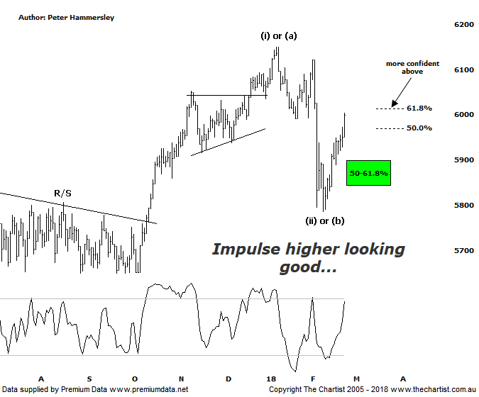

Bottom Line
23/2:
Daily Trend: Up
Weekly Trend: Down
Monthly Trend: Up
Support Levels: 5862 - 5797 / 5629 - 5611
Resistance Level: 6489 / 6851
Video Analysis
Watch Video Analysis Here
Technical Discussion
It’s been a big week for results here in Australia with the usual surprises causing some big moves. There are too many to discuss although there are a couple worthy of mentioning; BHP was one of the unlucky ones which got smashed when earnings were released, albeit it has recovered well over the past couple of days. A2M has been the exact opposite with their results triggering a massive gap higher on Wednesday although some profit-taking has set in which shouldn’t really come as a great surprise. Nothing moves higher in parabolic fashion without getting some type of a retracement. US indices continue their recovery after the recent bout of increased volatility and weakness with our market happy to follow, which of course isn’t always the case. In fact, over the past few days the ASX has outperformed which ideally is a trait that will continue although of course it still early days. So, what will next week bring? This week was the peak in terms of results although there are still plenty to come over the next few days. It’s also worth mentioning that there are plenty of companies going ex-dividend next week which is going to affect the XJO adversely. In terms of data, it’s all happening in the US next week with house prices, durable goods, vehicle sales, construction spending and pending home sales to watch. The beginning of the month will see global manufacturing PMI’s with China providing its services PMI on Wednesday.
Reasons to be cautious longer term:
→ US markets rebounding following high volatility.
→ A strong looking economy in Australia next year anticipated.
→ A weaker US dollar due to rising interest rates.
→ Broken back down through the psychological 6000 level.
→ Uncertainty regarding the Trump administration is a given these days but now he's aggressively posturing 'fire and fury' against North Korea.
→ The RBA governor Philip Lowe has suggested the next move for Australian interest rates will be up.
After seeing over a 5% decline in just a few days recently our market has been recovering well in line with US indices, which have also recovered part of their prior retracement. Both the XJO and the DOW have now headed into the typical retracement zones of the whole prior leg down that commenced in early January. In the case of our market, a push up through the 61.8% level at 6011 would be a bullish move, especially as it’s been impulsive up to this juncture which suggests it’s a resumption of the prior uptrend. However, that aforementioned level is still to be overcome although recent price action is looking positive which can only be a step in the right direction. As mentioned last week, it is feasible to count the recent leg lower as a 3-wave movement although the final leg down has extended significantly more than what would be deemed ideal. A couple of weeks ago we concentrated on the weekly chart which brings us back to the bullish trigger we’ve been watching for many months now sitting at 6490. In other words, we can’t quite count our chickens yet regarding seeing something much more bullish over the coming years. It still appears that a corrective pattern higher is unfolding from the early 2016 lows although I’ll be only too happy to be proven incorrect. At the end of the day we’d rather be holding stocks in a market that’s embarking on a strong bullish uptrend as opposed to a corrective pattern. We’d also rather make profits as opposed to putting forward perfect wave counts. Over the short-term the risk remains to be upside but it’s worth keeping a close watch on US indices which have started to close off sessions highs recently.
Trading Strategy
Our trade in Bank of Queensland (refer last night’s review) triggered today meaning we now hold 6 open positions with 3 waiting to trigger. Just a reminder that we make recommendations in the written reviews themselves even if the stock doesn’t make it into the position status page as a formal recommendation. JHX is a good example of this, which we also review this evening. There is still reason to be slightly cautious on the back of the massive increase in volatility recently although there is no reason to be out of the market. A small amount of exposure is fine (depending on your risk tolerance levels) if you are still a little nervous.

