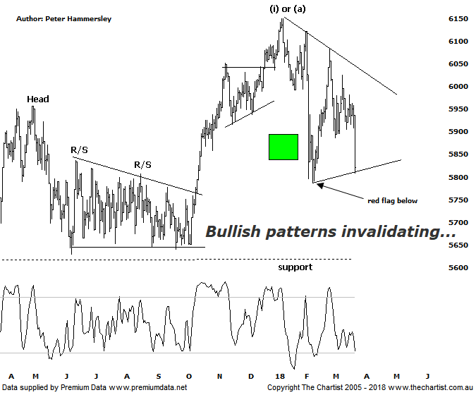

Bottom Line
23/3:
Daily Trend: Down
Weekly Trend: Down
Monthly Trend: Neutral
Support Levels: 5786 / 5629 - 5611
Resistance Level: 6489 / 6851
Video Analysis
Watch Video Analysis Here
Technical Discussion
After years of higher prices in US equity markets volatility increased substantially in early February which had a knock-on effect around the world. However, most analysts weren’t overly concerned as a one-off increase in volatility isn’t the end of the world and should even be expected. However, recently volatility has started to increase again, with last night’s performance on Wall Street pushing some panic buttons. Many headlines focused on the 700+ point sell-off in the Dow Jones overnight although in reality this is less than 3%. Not that I’m saying the fall was insignificant but it’s hardly “crash” material - at least not yet. However, it’s now clear that the decline that commenced in January, coupled with two bouts of volatility shows that all is not well, at least in respect to the strong multi-year uptrend resuming any time soon. The big question now is how deep the retracement is going to be - assuming it continues. Trying to second-guess this using fundamental analysis is next to impossible as there are arguments both for and against the bull market continuing. This is well documented in the press, so I won’t go into detail here although what we can say is that markets are forward-looking. Yes, the world economy is growing in unison, with most companies in the US recently presenting solid earnings with the added bonus of paying less tax. Although interest rates are rising there’s also no indication that inflation is going to fly out of control. On the face of it, everything is rosy. Again, this highlights the fact that markets move on future expectations and it could be argued that global growth has peaked. At the end of the day sentiment, by the way of fear and greed moves prices. This has always been the way forward and it always will be. The focus over the past few days has been on the trade war which appears to be escalating. This has overshadowed almost everything else although we must still concentrate on what lies ahead next week. In the US there’s income and spending data released which includes the PCE measure of inflation. This will be watched like a hawk. Pending home sales, consumer confidence and house prices is also something to look out for next week.
Reasons to be very cautious:
→ The Trump instigated trade war appears to be escalating.
→ US markets undergoing another bout of increased volatility.
→ A strong looking economy in Australia next year anticipated.
→ A weaker US dollar due to rising interest rates.
→ Broken back down through the psychological 6000 level.
→ Uncertainty regarding the Trump administration is a given these days , highlighted by the resignation of his senior economic adviser.
→ The RBA governor Philip Lowe has suggested the next move for Australian interest rates will be up.
This evening I’m going to take a look at both the daily and weekly charts which comes on the back of the increased volatility mentioned above. On the daily timeframe, today’s weakness means we’ve had to amend our symmetrical triangle which is now looking less than textbook to say the least. However, it’s technically a valid pattern and as such we’ll run with it until it’s invalidated which will likely be the case should price continue beneath today’s low. Should weakness continue we’ll have to start thinking in terms of a zigzag unfolding from the high made in early January. This projects a target down at 5719 which is where the wave equality projection sits. This would take price back down into the zone of support circa 5650 where we’d expect a few buyers to be waiting in the wings. Having seen the price action in US markets take a turn for the worse we must accept that the deeper retracement is now looking much more likely. For now, we’ll just concentrate on the aforementioned wave equality projection and see whether it holds are not. Now let’s focus on the weekly chart. Without wanting to sound like a broken record, our stance off the 2009 lows has always been that a corrective pattern higher has been unfolding. We’ve also had our line in the sand at 6489 to consider which still needs to be penetrated before thinking in terms of a multi-year trend unfolding. Not impossible, but it’s just not looking likely from an Elliott Wave point of view. Our expectation has been that a larger degree wave-B has been driving price higher which is part of a much larger corrective pattern. Should this prove itself there is scope to head all the way down toward the major zone of support around 5000 - 4300 which is obviously a hefty percentage loss from current levels. The typical retracement zone of the whole leg higher off the 2009 lows sits slightly beneath between 4558 - 4219 and is by no means off the agenda. To get down to those lows we are probably going to need some type of a catalyst although you wouldn’t bet against Donald Trump providing exactly that.
Trading Strategy
We now hold 5 long positions having just been triggered into BHP which was bad timing considering what transpired last night in the US - and flooded through to our market today. However, we have reduced the risk as much as possible recently with two stocks at breakeven. If you have full exposure in the market it may be an idea to reduce some of the risk. If you can’t sleep at night due to what may be happening in US markets it could be better to remain side-lined until volatility either decreases or a trend starts to materialise. We’ll continue to put setups forward although a few shorting opportunities could be presented over next few weeks for those wanting to still be involved. One thing is for sure, a big dose of caution is warranted currently.

