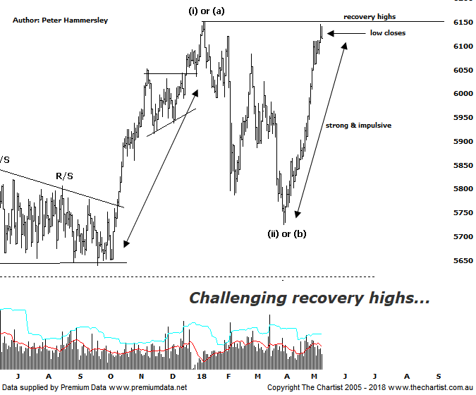

Bottom Line
11/5:
Daily Trend: Up
Weekly Trend: Up
Monthly Trend: Up
Support Levels: 5786 / 5629 - 5611
Resistance Level: 6489 / 6851
Video Analysis
Watch Video Analysis Here
Technical Discussion
On the news front there has been plenty of bad press for markets to digest over the past few months but although US markets have headed lower it’s hardly been a significant sell-off. Also, our local market has managed to buck the trend and stand on its own 2 feet. Headline news has been much better recently with US markets perking up over the past week or so. Inflation has been on many investors minds although with US monthly PPI being lower than expected, coupled with the CPI being similar, there’s no indication that inflation is going to be a major problem. The Russel small cap index is now within a whisker of all-time highs which is likely being helped by Trumps tax cuts. Earnings season has also been taken well by the market although of course there were already very high expectations. At least the market hasn’t been disappointed. The big news this week is that Kim Jong-un will meet Donald Trump on the 12th of June which is something that was looking highly unlikely just a few weeks ago. The focus is now on Iran although whether this will derail equity markets remains to be seen. There are too many AGMs to mention next week although there will be a drag on our market with the likes of ANZ, WBC, MQG & NAB all going ex-dividend. Minutes are also released from the RBA meeting next week with March quarter wage price index and April jobs numbers. Overseas, China releases monthly industrial production numbers, fixed asset investment data and retail sales data. The pick out of the US is retail sales, industrial production and housing sentiment.
Reasons to be cautious:
→ Geopolitical risk subsided but still evident.
→ The Trump instigated trade war could still escalate.
→ US markets recently retracing.
→ A strong looking economy in Australia next year anticipated.
→ A weaker US dollar due to rising interest rates.
→ Back above the psychological 6000 level.
→ Uncertainty regarding the Trump administration is a given these days, highlighted by the resignation of several staff.
→ US markets now in correction territory.
As mentioned above, the XJO has been outperforming, which is especially significant considering that the likes of the Dow Jones have been struggling for traction. However, last week we also noted that on the chart of the Dow, a bullish descending triangle was in place with price posturing for an upside breakout. The risk was to the upside and we haven’t been disappointed with the upper boundary of the pattern being overcome over the past few sessions. Yes, the XJO has been stronger recently although we won’t complain should US markets provide a helping hand over the coming weeks and months. As far as the patterns are concerned, it’s no secret that we haven’t been overly enamoured with them over recent months as they lack clarity from an Elliott stance. The patterns will become much more bullish if our line in the sand at 6490 is overcome although until that transpires we need to use more conventional pattern analysis. The good news is that over the past few months we’ve noted that the patterns on the Small Ordinaries (XSO) have been showing much more clarity whilst also looking bullish. That index has been leading the way which is ideally a trait that will continue as it keeps the risk to the upside. Back to this chart shows that the recovery high made in January of this year at 6150 came within a whisker of being tagged both yesterday and today although weak closes have been the way forward. This isn’t major reason for concern at this stage, especially when considering how potent the trend has been over the past few weeks. In fact, it wouldn’t come as any surprise to see a small consolidation or even an a-b-c correction before the next attempted leg higher kicks in.
Trading Strategy
It’s noticeable that all our portfolios have had increased activity recently which simply comes on the back of recent strength in the market. As long as the patterns continue to form and present low risk entries, setups will continue to be put forward. Some breakouts are still failing to hold, with WSA being one that comes to mind. In fact, we have taken defensive action and were stopped out of our long position for a small loss yesterday. We currently hold six long positions with most performing very well over the past few weeks. I’ll be looking to add to this number if the broader market continues to rally although it’s worth mentioning that we added a setup in CTD this evening which is an exceptionally strong trending stock.

