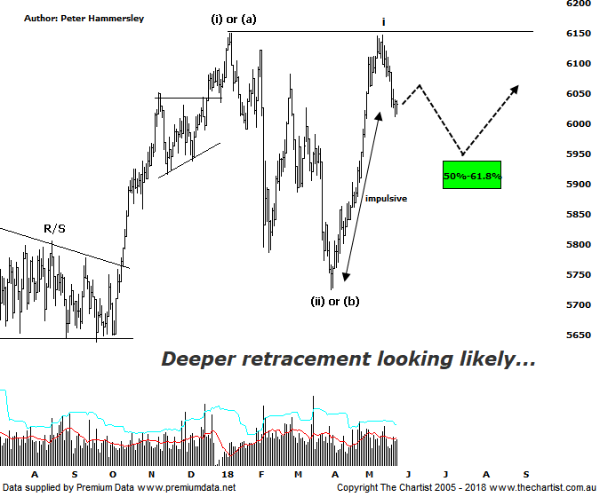

Bottom Line
25/5:
Daily Trend: Down
Weekly Trend: Up
Monthly Trend: Up
Support Levels: 5786 / 5629 - 5611
Resistance Level: 6489 / 6851
Video Analysis
Watch Video Analysis Here
Technical Discussion
The big news this week is that Donald Trump called off the meeting with North Korea which followed KIM Jong-un doing exactly the same with the South Korean president. Reportedly, a North Korean official stated that if the meeting was cancelled with the US, there would be a showdown although this is nothing we haven’t heard before. US markets ended lower on the news although not significantly so; also, buyers stepped up pretty much immediately and bought into the weakness. Gold is seen as a safe-haven and not surprisingly headed higher, climbing back above $1300 an ounce. Whether it can remain above that level for a decent period of time is open to debate. In other news, OPEC have stated that they will consider an increase in production at their next meeting in June which comes on the back of decreased production from Iran and Venezuela. This caused some profit-taking, with the energy sector heading south. Data out of the US next week increases with consumer confidence, private sector jobs, personal income and spending, manufacturing PMI, pending home sales, house prices and vehicle sales due. Fridays non-farm payrolls report will likely be the pick of the bunch and watched carefully by the FED. US markets are closed on Monday for Memorial Day. Here in Australia, private sector credit, building approvals and March quarter capital expenditure and Intentions reports will be released.
Reasons to be cautious:
→ Geopolitical risk subsided but still evident.
→ The Trump instigated trade war could still escalate.
→ US markets recently retracing.
→ A strong looking economy in Australia next year anticipated.
→ A weaker US dollar due to rising interest rates.
→ Back above the psychological 6000 level.
→ Uncertainty regarding the Trump administration is a given these days, highlighted by the resignation of several staff.
→ US markets now in correction territory.
Due to big picture week it’s been a couple of weeks since our last look at the daily chart of the XJO, where price was taking on a minor line of resistance which coincided with recovery highs. We also noted that low closes were starting to appear which was an early warning sign. Although it hasn’t been a significant sell-off, weakness has been the main theme recently and there is still downside potential ahead. The big positive is the impulsive nature of the leg higher off the early April lows which was almost a straight-line move. Therefore, it doesn’t come as any great surprise that a retracement has been unfolding. Interestingly, our local market has become a little more independent and has been diverging from US markets, heading higher during US weakness whilst retracing as the likes of the DOW have been heading higher. At least the XJO isn’t quite as skittish as it has been over the years which must be a small step in the right direction. Back to this chart shows that the typical retracement zone of the whole leg higher from wave-(ii) or-(b) is drawing closer which is the next inflection point. If we are to head down to those lower levels circa 5900 it’s important that a corrective pattern takes us there. Although the leg down off the January high was a deep pull-back, at least in was a corrective pattern and completed as a 3-wave move; it’s important that the same transpires should price head down into our target area. Another straight-line movement South would ring the alarm bells and put our already tentative wave count under even more pressure. For now, there’s no need to be overly alarmed although the risk is to the downside over the coming weeks.
Trading Strategy
It was always going to be difficult for our market to continue higher without getting some type of a pause, especially when taking on previous significant highs. Also, it was a big ask to continue at the rate of knots witnessed off the early April low, especially without the help of the big four banks which account for a large proportion of the market (almost 30%). The big miners like BHP & RIO have been doing their best to drag the XJO higher but it’s a big ask to continue with the momentum seen over the past few weeks which has been exceptional. We have been tightening protective stops in our trades recently with many performing very well in a short period of time. However, opportunities continue to present themselves and if this trait continues more setups will be forthcoming.

