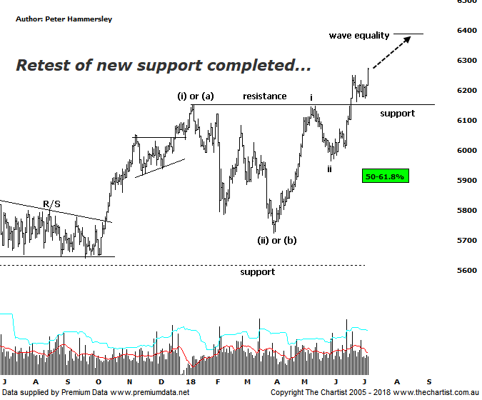
Bottom Line
6/7:
Daily Trend: Up
Weekly Trend: Up
Monthly Trend: Up
Support Levels: 6150 / 5786 / 5629 - 5611
Resistance Level: 6489 / 6851
Video Analysis
Watch Video Analysis Here
Technical Discussion
The so-called “trade war” may be affecting US markets although nothing could be further from the truth over here. The XJO flatly refuses to be swayed by the potential headwinds that a trade war could trigger. In fact, our market is looking robust, albeit it’s undoubtedly being helped by the stronger performance from the banks which is masking some weakness elsewhere in the market. If the trade war escalates, many analysts believe the global economy could be pushed into recession. As always though, there are counterarguments. In a recent investor presentation by Rio Tinto, they stated that trade tensions were unlikely to materially affect steel demand. Indeed, they noted “strong external demand for Chinese exports despite an increase in trade tensions”. The real risk to Australia if the situation blows up is lower commodity prices, plus the effect on tourism. A China slowdown will also impact on the supply chain within Southeast Asia. At this stage, it’s a known unknown and we must simply let the story unfold. Regarding data, tonight sees US jobs numbers for June released. There is also US June quarter earnings season to consider which kick off on Friday with the large banks being centre stage. CPI inflation and consumer sentiment data is also being released. In China, trade numbers and June inflation will be watched.
Reasons to be more optimistic:
→ Price has broken up through recovery highs.
→ US market weakness is being ignored.
→ A strong looking economy in Australia next year anticipated.
→ A weaker US dollar due to rising interest rates.
→ Back above the psychological 6000 level.
→ A potential trade war with China largely being ignored.
→ The Banking Sector finally providing a helping hand.
Our stance last week was to remain bullish unless the new line of support was breached, which we are pleased to say hasn’t been the way forward. Price has been consolidating although today buyers stepped up once again resulting in a strong close and again of near 1% which was a solid effort considering lacklustre price action overseas. As mentioned above, the banks have been providing a helping hand which has painted a slightly rosy picture which is reiterated when looking at the chart of the Small ordinaries (XSO) which has been underperforming recently. We’ll look at the XSO next week although suffice to say there’s no reason to panic at this stage with current weakness being perfectly healthy in the bigger scheme of things. Should strength continue in the broader market next week, a push up through 6249 would be ideal as it would set the stage for the leg higher that commenced in April this year to continue. A rotation up toward 6386 would be our minimum expectation though let’s not forget our line in the sand at 6490, as this level will need to be overcome before moving to a firmer bullish stance medium to longer-term. For now though, we’ll sit back and enjoy the fact that finally we are outperforming US markets! It’s been a long time coming.
Trading Strategy
Many of the stocks we are involved with have been consolidating recently although these have generally followed strong trends. Once the consolidation phases have run their course we’ll be in a position to see those trends resume. Setups have been light on the ground recently which as mentioned above is largely due to the strength of the banks which have given a boost to the index. That said, there is still no reason to be out of this market irrespective of the potential bearish catalyst of an escalating trade war; of course, it could just as easily prove to be a damp squid which would be ideal.

