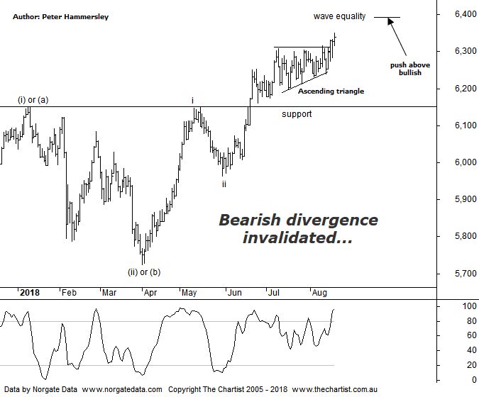

Bottom Line
17/8:
Daily Trend: Up
Weekly Trend: Up
Monthly Trend: Up
Support Levels: 6150 / 5786 / 5629 - 5611
Resistance Level: 6489 / 6851
Video Analysis
Watch Video Analysis Here
Technical Discussion
This week has been all about the potential trade war although talks are back on with the Chinese sending a delegation to Washington following an invitation. That said, it appears to be lower-level although at least it’s a start. You get the feeling this story is only part of the way through, with volatility yet to come further down the track. This week has seen plenty of results over here in Australia with Telstra yesterday surprising the market with a special dividend. The end result was a gain of over 5% although whether it proves to be the initial stages of something more bullish is debatable to say the least. CSL is another company that has just reported earnings which the market once again appearing to like. This has been a trait over recent years as the company continues to surprise to the upside. It hasn’t all been good news though with ILU & IVC just a couple out of several that disappointed, resulting in significant declines. Earnings season is in full flow so expect further volatility, both good and bad. After some weakness, US indices were stronger overnight, especially the Dow Jones which rallied around 1.6%. This is mainly due to the large industrial stocks which tend to move quite aggressively on news of trade talks. The S&P 500 rallied 0.8%. It’s a fairly quiet week on the data front although the US sees house prices, durable goods orders and new-home sales, plus the minutes of the last Fed meeting are due mid-week. Thursday sees talks begin between China and the US on trade. It’s an exceptionally busy next week in Australia for earnings with far too many to mention.
Reasons to be more optimistic:
→ Price has broken up through recovery highs.
→ US market weakness is being ignored.
→ A strong looking economy in Australia next year anticipated.
→ A weaker US dollar due to rising interest rates.
→ Back above the psychological 6000 level.
→ A potential trade war with China largely being ignored.
→ The Banking Sector finally providing a helping hand.
We’ve been talking about the bearish divergence on this daily chart for several weeks now as it continued to linger. It’s no doubt been holding price back although it’s no longer a headwind. Recent strength has meant that our indicator has now headed back into the overbought position and although this may seem less than ideal it’s not reason for concern, especially as the divergence has now invalidated. Usually of course it proves to be significant although on this occasion we aren’t complaining as it’s opened the door for higher prices. The pattern of interest has been the ascending triangle which has meant choppy price action has been the trait over the past month or so. Over the past couple of days price has headed higher out of the pattern and although the move hasn’t been exceptionally strong, it can only be viewed in a positive light. The wave equality projection sits up at 6386 although this is by no means a high probability reversal zone. It’s simply where wave-iii will be the same length as wave-i which is our minimum expectation. Normally the third leg extends meaning a push above that target portends a continuation up toward the 1.618 projection at 6647. The significance of this is that it will also result in our line in the sand on the weekly chart (not shown) at 6490 being overcome, resulting in us amending the wave count on that larger timeframe for the better. We’ll keep this scenario on the back burner for the moment until that make or break level is overcome. Talking of the weekly chart, there is a large Cup & handle pattern in play which offers plenty of upside. We''l take a look during this evenings video. All we can do for now is take one pattern and one step at a time and see if the bullish triggers mentioned can be overcome.
Trading Strategy
On the whole, earnings season has been kind to us regarding our long positions with CSL continuing to prove itself. The one laggard has been ILU which we exited a few days ago for a small loss, just before results triggered significant weakness. Again, this reiterates the importance of protective stops. We currently hold 7 long positions with setups also waiting to trigger. We’ll add to these should bullish patterns continue to show themselves.

