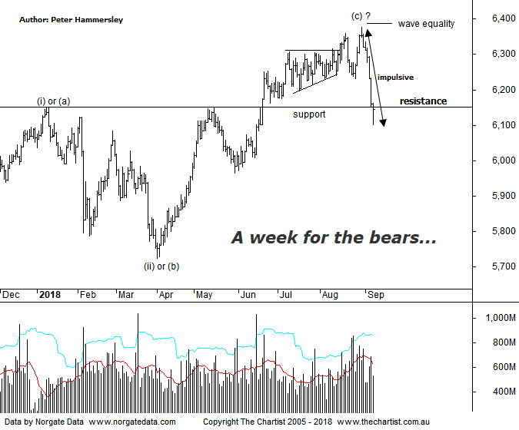

Bottom Line
7/9:
Daily Trend: Down
Weekly Trend: Down
Monthly Trend: Up
Support Levels: 5786 / 5629 - 5611
Resistance Level: 6150 / 6489 / 6851
Video Analysis
Watch Video Analysis Here
Technical Discussion
With reporting season over, it would be a good idea to assess the statistics over the past few weeks. According to FNArena, just short of 50% of companies broadly met guidance and expectations. 28% produced better results with 24% disappointing. The consensus is that earnings season this time around wasn’t particularly good or bad – it was generally as expected. With results out of the way, investors will be turning to overseas markets for leads. US markets continue to perform well although it appears that our local market has got the jitters simply because the likes of the S&P 500 have been treading water as opposed to heading higher in a straight-line move. Nothing new there as this has been the main theme for many years. We were hopeful that this trait was changing but it could be a case of wishful thinking. The sell-off in the XJO over the past couple of days could be attributed to trade war tensions and concerns regarding emerging markets. Whatever the reason, profit-taking has set in bringing the index to an important level which we’ll discuss below. There’s not too much happening on the data front next week although US non-farm payrolls are due tonight. In China, trade and inflation numbers are released which is more significant as the China slowdown story is making headlines once again. Here in Australia, the Westpac consumer confidence survey, National Australia Bank business survey and August jobs numbers are due next week. It’s also worth noting that many stocks go ex-dividend next week.
Reasons to be slightly cautious:
→ Fears regarding a potential trade war have heightened.
→ Tightening US monetary conditions.
→ Cracks are starting to appear in markets that are rarely discussed in the general media, i.e. credit markets
→ Inflation looks to remain stagnant till at least 2020
→ The Australian dollar is at risk of declining significantly
→ A strong sell-off has taken price down through a line of support.
Our headline last week was “… Struggling to maintain traction…” as strength continued to be sold into. This week we needed to see the wave equality projection as annotated overcome to become more confident although clearly not to be. Not only has weakness transpired this week but it’s been a very strong almost parabolic movement lower which in itself is concerning. It’s also worth noting that volume has picked up recently which suggests it’s not just a few mum and dad investors taking profits. The most important thing to take away from this chart though is that overlap has occurred which means it’s much more likely that a corrective pattern higher has been unfolding off the October 2017 lows. This is a good time to remind ourselves that our view has always been that a bounce only has been unfolding off the 2009 lows, albeit a substantial one. We’ve had our line in the sand in place for what seems like an eternity. This sits at 6490 and still needs to be overcome before looking at the larger degree patterns in a more bullish light. Should price continue to impulse lower it is feasible that it comes all the way back down to the early 2016 lows around 4700 to complete a much larger flat correction. We may look at the larger degree patterns on the weekly chart next week, especially if recent weakness continues. It’s important to be aware of lower target areas should this prove to be the initial stages of a deeper retracement. This would be deemed the worst-case scanario and it’s far too early to be suggesting a sell-off of that significance is going to occur following just one week of weakness. Either way, plenty of caution is required over the short-term.
Trading Strategy
We have been aggressive with protective stops lately resulting in four positions being closed this week which leaves us with 5 open trades. Healthcare has suffered, with CSL taking a hit over the past couple of sessions. We closed our position on open this morning to lock in a decent profit which was the same situation with CTD. It hasn’t all been good news though with resource stocks getting clobbered over the past couple of weeks although we currently only hold Mineral Resources. It may be wise to limit exposure to the market over next week or two, or at least until the dust settles.

