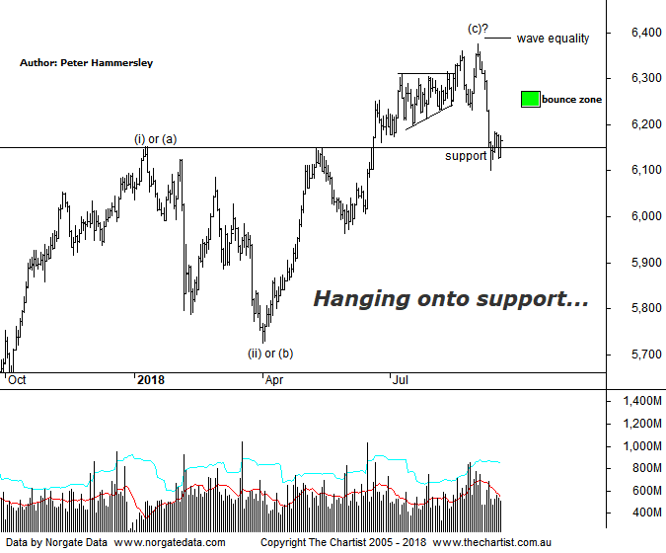

Bottom Line
14/9:
Daily Trend: Down
Weekly Trend: Down
Monthly Trend: Up
Support Levels: 6102 / 5786 / 5629 - 5611
Resistance Level: 6373 / 6489 / 6851
Video Analysis
Watch Video Analysis Here
Technical Discussion
It's been a better week for our local market, especially as plenty of companies went ex-dividend which is always a drag. That said, it wasn’t going to be difficult to outperform the prior week which was very poor. The only bright spot last Friday was that price broke down through a line of support which immediately brought out the buyers resulting in a closed near the highs of the session. Although this week has undoubtedly been an improvement price is still hovering around a line of resistance/support although we’ll talk about this in more detail below. Wall Street has been doing its best to provide a helping hand as the S&P 500 continues to head into blue sky territory. The Dow Jones isn’t too far behind, having broken through the upper boundary of a descending triangle a few weeks ago. If traction in the US can continue we may be able to avoid a deeper retracement although I’m not holding my breath. News overnight that the White House has invited China back to the trade table also helped market sentiment resulting in a good performance. On the data front, the US sees existing home sales, housing sentiment and starts, along with flash estimate of September PMI. Here in Australia, TPG Telecom release earnings while Sydney airport provides monthly traffic numbers. Suncorp also holds its AGM.
Reasons to be slightly cautious:
→ Fears regarding a potential trade war have heightened.
→ Tightening US monetary conditions.
→ Cracks are starting to appear in markets that are rarely discussed in the general media, i.e. credit markets
→ Inflation looks to remain stagnant till at least 2020
→ The Australian dollar is at risk of declining significantly
→ A strong sell-off has taken price down through a line of support.
Although it has been a better week for the XJO we’ve only clawed back a tiny percentage of the leg down that commenced at the end of August. Much is now going to depend on how any rally unfolds (assuming it does) and whether it’s choppy and messy in nature or impulsive. We still favour the prior which comes down to the fact that it was a straight-line movement down to the pivot low made last Friday which in theory should not complete a corrective pattern, at least not at this degree of trend. I’ve also put forward the 50% - 61.8% retracement zone of the prior leg down on the chart which should be our focal point over the coming weeks should strength continue. It would take a push above the upper boundary at 6272 before thinking in terms of a significant low being locked in. The further price gets up through the target area, the more bullish we become albeit a larger corrective pattern could still be unfolding, perhaps a flat pattern or another triangle. One thing is for sure, a push down through the recent pivot low at 6102 would be a backward step and set the stage for further declines. We have lower target areas on the weekly chart although we won’t go into details now. I’ll be updating the larger degree patterns shortly, especially if price pushes down through the area of support following a lacklustre bounce. The bottom line is that some caution is still required.
Trading Strategy
We are now down to 4 open positions which comes on the back of us tightening protective stops over the past couple of weeks. However, some bullish patterns have presented themselves this week and we currently have 4 pending orders waiting to trigger with S32 & A2M added to the list this week. If you want more opportunities, don’t forget that we often put setups in the reviews themselves even if they don’t make it into the position status page. Should the zone of support here give way there should be a few shorting opportunities presented over the coming weeks for those interested.

